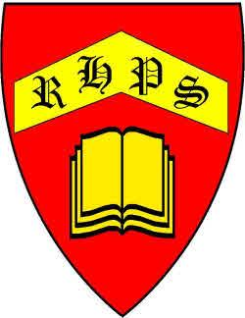
Working together to be the best that we can be

DECLARATION OF INTERESTS
GOVERNING BODY
RUSSELLS HALL PRIMARY SCHOOL
YEAR 2022 / 2023

Name | Position | Interest  Organisation | Nature of  Interest | Date of Interest was  registered
Mrs Saima Naz | Chair Governor  Co-opted | Pupil | Parent of a  Child at school | March 2022
Mrs Dawn Elsom | Co-opted  Governor | None | Nil | March 2022
Mr Andy Page | Co-opted  Governor | None | Nil | March 2022
Mrs Sarah Baig | Co-opted  Governor | Pupil | Parent of a  Child at school | March 2022
Mr John Cook | Parent  Governor  Vice | Wife and  Pupil | Employee  Parent of a child  At school | March 2022
Miss Charlotte Saul | Staff  Governors | None | Nil | March 2022
Mrs Peta-Gaye Gordon | Parent  Governor | Pupil | Parent of a  Child at school | January 2023
Mr Michael DaCosta | Co-opted  Governor | Pupil | Parent of a  Child at school | January 2023
Mrs Sarah Hawker | Observer | None | Nil | March 2022

