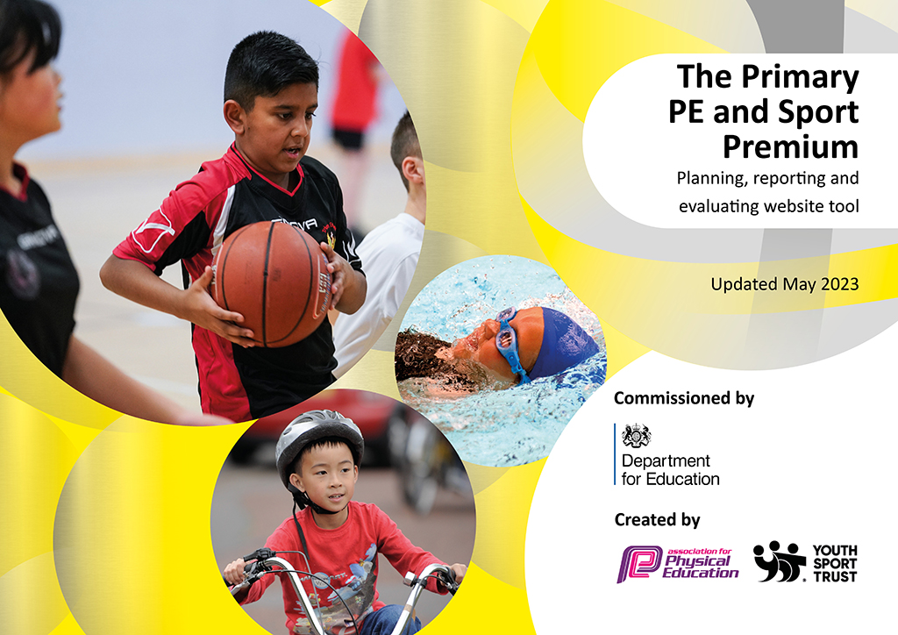
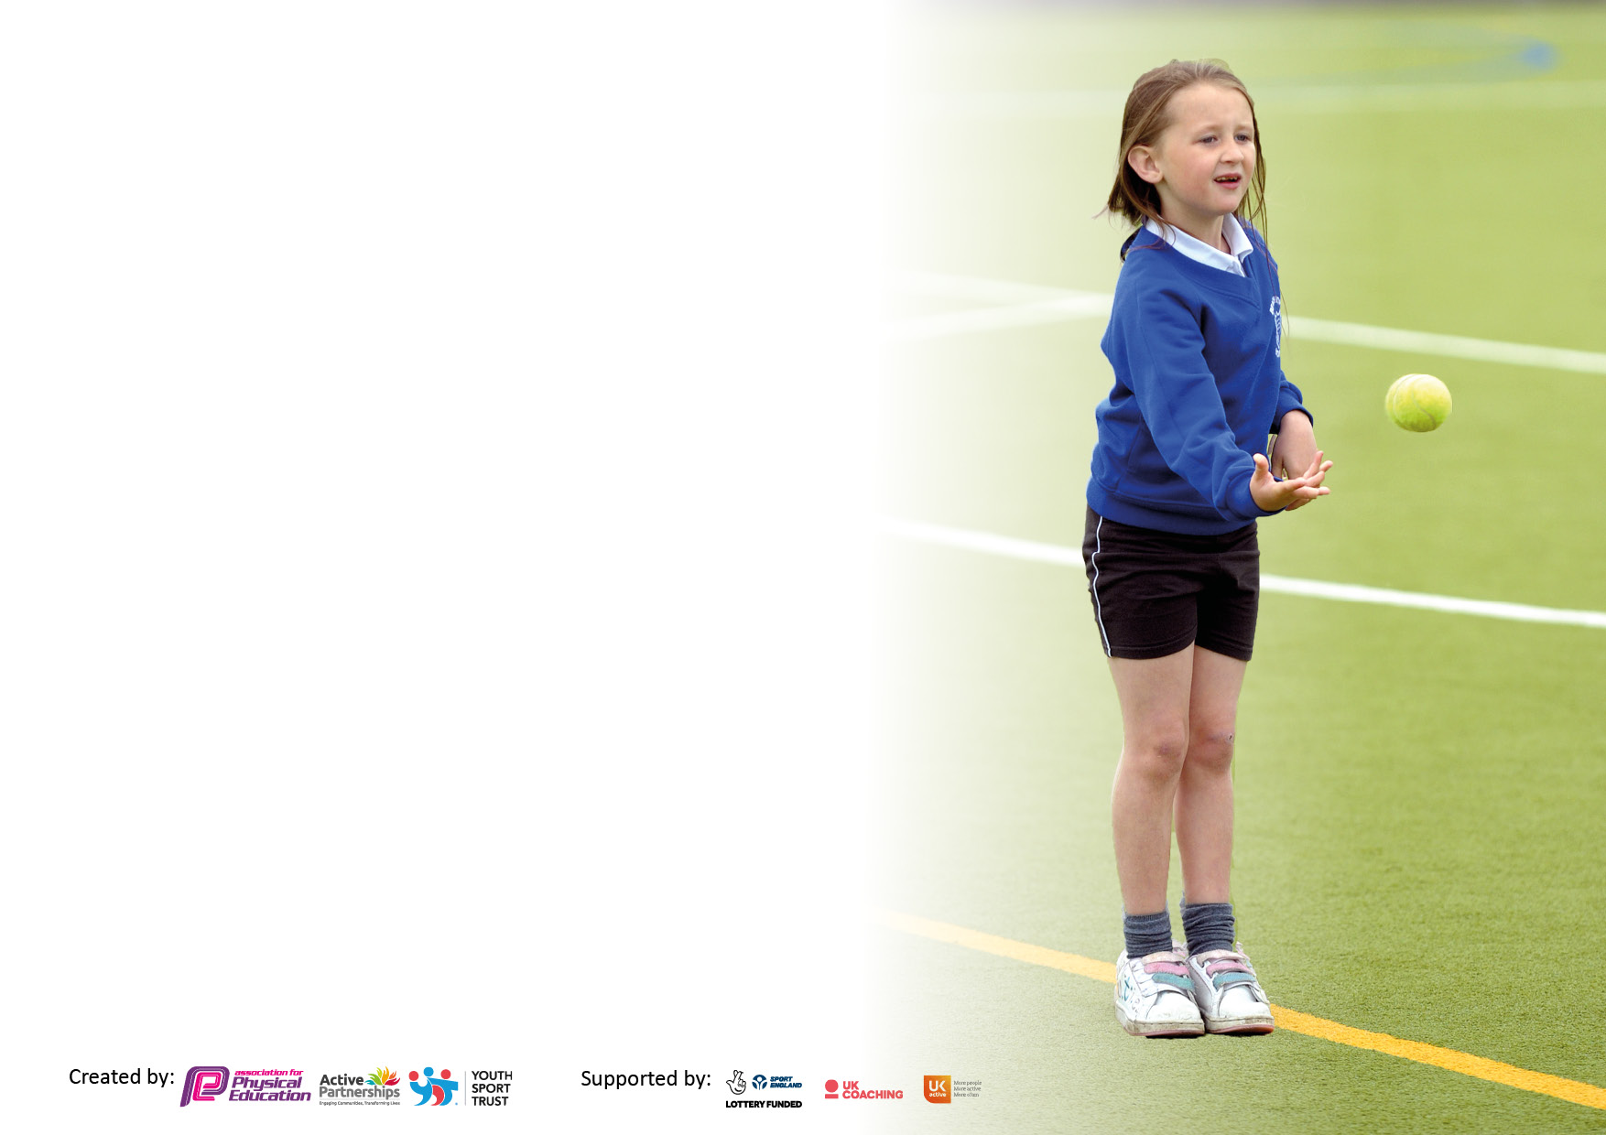

It is important that your grant is used effectively and based on school need. The Education Inspection Framework makes clear there will be a focus on ‘whether leaders and those responsible for governors all understand their respective roles and perform these in a way that enhances the effectiveness of the school’.

Under the Quality of Education Ofsted inspectors consider:
Intent - Curriculum design, coverage and appropriateness
Implementation - Curriculum delivery, Teaching (pedagogy) and Assessment
Impact - Attainment and progress

To assist schools with common transferable language this template has been developed to utilise the same three headings which should make your plans easily transferable between working documents.

Schools must use the funding to make additional and sustainable improvements to the quality of Physical Education, School Sport and Physical Activity (PESSPA) they offer. This means that you should use the Primary PE and sport premium to:

- Develop or add to the PESSPA activities that your school already offer
- Build capacity and capability within the school to ensure that improvements made now will benefit pupils joining the school in future years
- The Primary PE and sport premium should not be used to fund capital spend projects; the school’s budget should fund these.

Please visit gov.uk for the revised DfE guidance including the5keyindicatorsacrosswhichschoolsshoulddemonstrate an improvement. This document will helpyoutoreviewyourprovisionandtoreportyourspend.DfEencouragesschools to use this template as an effective way of meeting the reporting requirements of the Primary PE and Sport Premium.

We recommend you start by reflecting on the impact of current provision and reviewing the previous spend.

Schools are required to publish details of how they spend this funding, including any under-spend from 2021/2022, as well as on the impact it has on pupils’ PE and sport participation and attainment. The funding should be spent by 31st July but the DfE has stated that there will be no clawback of any unspent money so this can be carried forward into 2023/24.

We recommend regularly updating the table and publishing it on your website throughout the year. This evidences your ongoing self-evaluation of how you are using the funding to secure maximum, sustainable impact. Final copy must be posted on your website by the end of the academic year and no later than the 31st July 2023. To see an example of how to complete the table please click HERE.

Details with regard to funding
Please complete the table below.

Total amount carried over from 2021/22 | £0
Total amount allocated for 2021/22 | £19,550
How much (if any) do you intend to carry over from this total fund into 2022/23? | £0
Total amount allocated for 2022/23 | £ 19,480
Total amount of funding for 2022/23. Ideally should be spent and reported on by 31st July 2023. | £ 19,480
Swimming Data
Please report on your Swimming Data below.

Meeting national curriculum requirements for swimming and water safety.

N.B. Complete this section to your best ability. For example you might have practised safe self-rescue techniques on dry land which you can then transfer to the pool when school swimming restarts.
Due to exceptional circumstances priority should be given to ensuring that pupils can perform safe self rescue even if they do not fully meet the first two requirements of the NC programme of study
What percentage of your current Year 6 cohort swim competently, confidently and proficiently over a distance of at least 25 metres?  N.B. Even though your pupils may swim in another year please report on their attainment on leaving primary school at the end of the summer term 2023.  Please see note above | 36.67%
What percentage of your current Year 6 cohort use a range of strokes effectively [for example, front crawl, backstroke and breaststroke]?  Please see note above | 35%
What percentage of your current Year 6 cohort perform safe self-rescue in different water-based situations? | 71.67%
Schools can choose to use the Primary PE and sport premium to provide additional provision for swimming but this must be for activity over and above the national curriculum requirements. Have you used it in this way? | Yes

Action Plan and Budget Tracking
Capture your intended annual spend against the 5 key indicators. Clarify the success criteria and evidence of impact that you intend to measure to evaluate for pupils today and for the future.

Academic Year: 2022/23 | Total fund allocated: £19,480 | Date Updated: 14.07.23
Key indicator 2: The engagement of all pupils in regular physical activity – Chief Medical Officers guidelines recommend that primary school pupils undertake at least 30 minutes of physical activity a day in school |  |  |  | Percentage of total allocation:
 |  |  |  | 40.25%
Intent | Implementation |  | Impact
Your school focus should be clear what you want the pupils to know and be able to do and about  what they need to learn and to  consolidate through practice: | Make sure your actions to achieve are linked to your intentions: | Funding allocated: | Evidence of impact: what do pupils now know and what can they now do? What has changed?: | Sustainability and suggested next steps:
To provide additional opportunities for children to access sporting activities, encouraging the engagement of children undertaking at least 30 minutes of physical activity. | We provide additional after-school clubs such as: football, multi-sports and dance.  We provide additional lunch time coaching sessions such as: basketball, hockey, football, dodgeball, handball and dance.  Funding is used to provide coached sessions at lunch time and coaches for after-school clubs. | £7480 | Since Covid-19, our after school club participation was low – down to only one club that could be taught outside in all weathers. (Football club – max 30 children in the same year groups)  We now have multiple after-school clubs equaling 120 children from Years 1-6).  Children are more active at lunch time due to coaching sessions and our OPAL initiative. | Continue to develop our after-school club offer, increasing the variety of sport available to encourage a higher participation rate.  Current participation rates are at 34.44% for Years 1-6. We would like this to increase next year.  Continue to offer a range of sports at lunch time to encourage more children to take part in dedicated sessions.  24.56% of PP children currently access after-school clubs.  28.99% of SEND children currently access after-school clubs.  We would like to continue increasing these figures.
Key indicator 3: The profile of PESSPA being raised across the school as a tool for whole school improvement |  |  |  | Percentage of total allocation:
 |  |  |  | 0%
Intent | Implementation |  | Impact
Your school focus should be clear what you want the pupils to know and be able to do and about  what they need to learn and to  consolidate through practice: | Make sure your actions to achieve are linked to your intentions: | Funding allocated: | Evidence of impact: what do pupils now know and what can they now do? What has changed?: | Sustainability and suggested next steps:
To encourage a whole school ethos of a passion for sport and physical activity. | CPD for staff to improve whole school confidence in teaching.  After-school clubs to show all year groups the importance of physical activity.  Lunchtime coaching and OPAL initiative, giving children a love of creativity and physical activity.  School Sport Minister as part of our Pupil Parliament.  Taking part in competitions, encouraging a love of competition and activity in all year groups.  Improvement of sports equipment. | £0 (see other indicators) | There has been an increase in children’s motivation to take part in extra coaching, clubs and competitions, regularly requesting more! | Continue to build this enthusiasm, with PE assemblies, more after-school clubs, lunch-time clubs, intra school competitions and an importance of physical activity emphasised in every lesson.  47.4% of children currently say they love PE (rated 5 out of 5) and a further 28.9% say that they enjoy it (rated 4 out of 5).  We would like to see this figure grow in the coming years.

Key indicator 1: Increased confidence, knowledge and skills of all staff in teaching PE and sport |  |  |  | Percentage of total allocation:
 |  |  |  | 43.88%
Intent | Implementation |  | Impact
Your school focus should be clear | Make sure your actions to | Funding | Evidence of impact: what do | Sustainability and suggested
what you want the pupils to know | achieve are linked to your | allocated: | pupils now know and what | next steps:
and be able to do and about | intentions: |  | can they now do? What has
what they need to learn and to |  |  | changed?:
consolidate through practice:
Our school had 2 out of 11 teachers who were not confident in their knowledge of the PE curriculum as well as two ECT’s. | We employed a CPD coach to 3 members of staff throughout the year, monitoring their confidence in teaching PE | £8547 | We now have 3 members of staff who have received CPD throughout the year in all sports.  We have 5 further members of staff who have received subject specific CPD.  This will help us to build upon the whole staff’s confidence levels. | Continue to ensure there is high quality CPD provision for all teachers, monitoring confidence levels, and targeting specific sports.
Key indicator 4: Broader experience of a range of sports and activities offered to all pupils |  |  |  | Percentage of total allocation:
 |  |  |  | 12.83%
Intent | Implementation |  | Impact
Your school focus should be clear | Make sure your actions to | Funding | Evidence of impact: what do | Sustainability and suggested
what you want the pupils to know | achieve are linked to your | allocated: | pupils now know and what | next steps:
and be able to do and about | intentions: |  | can they now do? What has
what they need to learn and to |  |  | changed?:
consolidate through practice:
Top up swimming sessions for those children who may have been affected during the Covid-19 crisis.  Equipment to continue the wide variety of sports available to be taught. | Allowing children who wouldn’t be able to outside of school, the opportunity to access swimming lessons.  Allowing children to experience more obscure sports, such as curling, tri-golf and OAA activities. | £2,500.20 | Children are now more confident in safe swimming as they have had access to swimming, with 71.67% being safe in the water. | Continue to check equipment and offer top up swimming sessions when appropriate.  Swimming will continue to be accessed at an earlier age, allowing us to pin point and provide more targeted top up sessions if required.

Key indicator 5: Increased participation in competitive sport |  |  |  | Percentage of total allocation:
 |  |  |  | 3.04%
Intent | Implementation |  | Impact
Your school focus should be clear | Make sure your actions to | Funding | Evidence of impact: what do | Sustainability and suggested
what you want the pupils to know | achieve are linked to your | allocated: | pupils now know and what | next steps:
and be able to do and about | intentions: |  | can they now do? What has
what they need to learn and to |  |  | changed?:
consolidate through practice:
Take part in as many inter-school competitions as possible, to continue to build an ethos of teamwork and competition.  Develop intra-school competitions to build this further inside of school. | We have taken part in a girls and mixed football league.  We have also taken part in 6 inter-school competitions.  We have had each year group take part in sports days, which are based on a competition between the school’s four house groups. | £592.80 | Children are beginning to enjoy competing more and more, showing a resilience if they do not win.  Children are developing a sense of community and belonging through their team work. | Continue to encourage the school to take part in inter-school competitions.  Develop more intra-school competitions throughout the school year.  Continue to take part in leagues.

Signed off by
Head Teacher: | Alison Harrison
Date: | 19/7/23
Subject Leader: | Mrs S Ridley
Date: | 19.07.2023
Governor: | Saima Naz
Date: | 20/7/23

