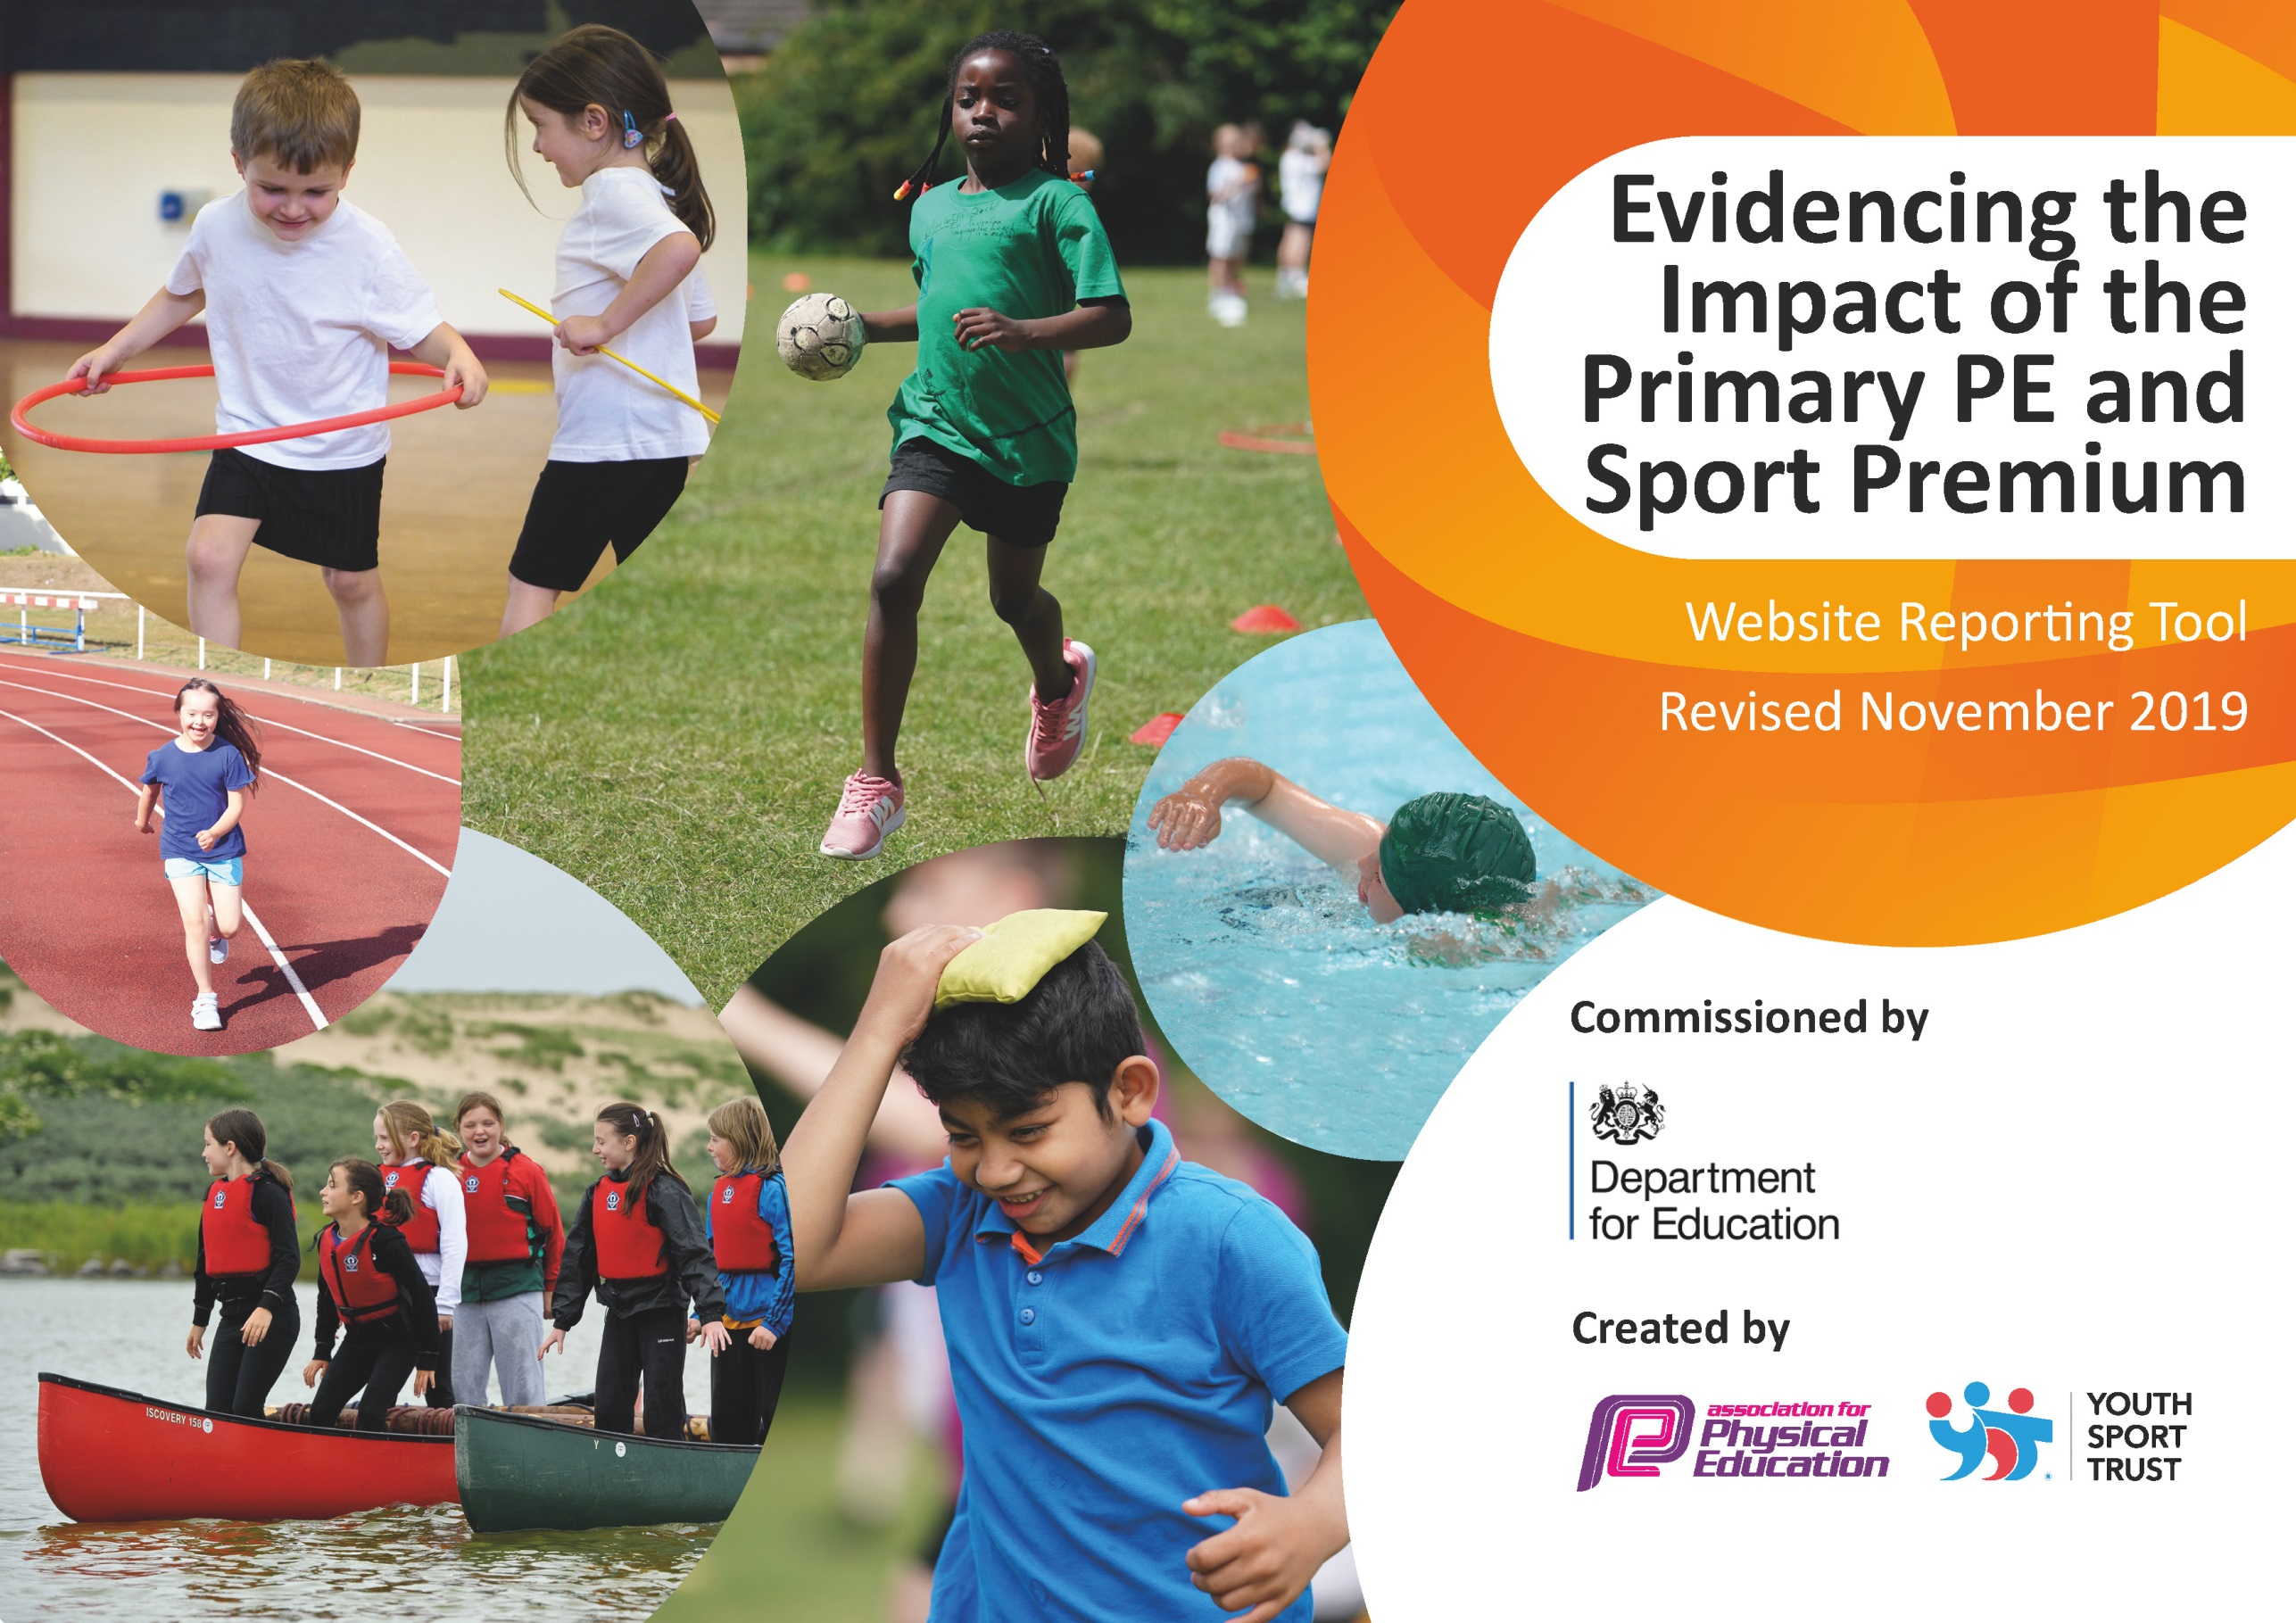
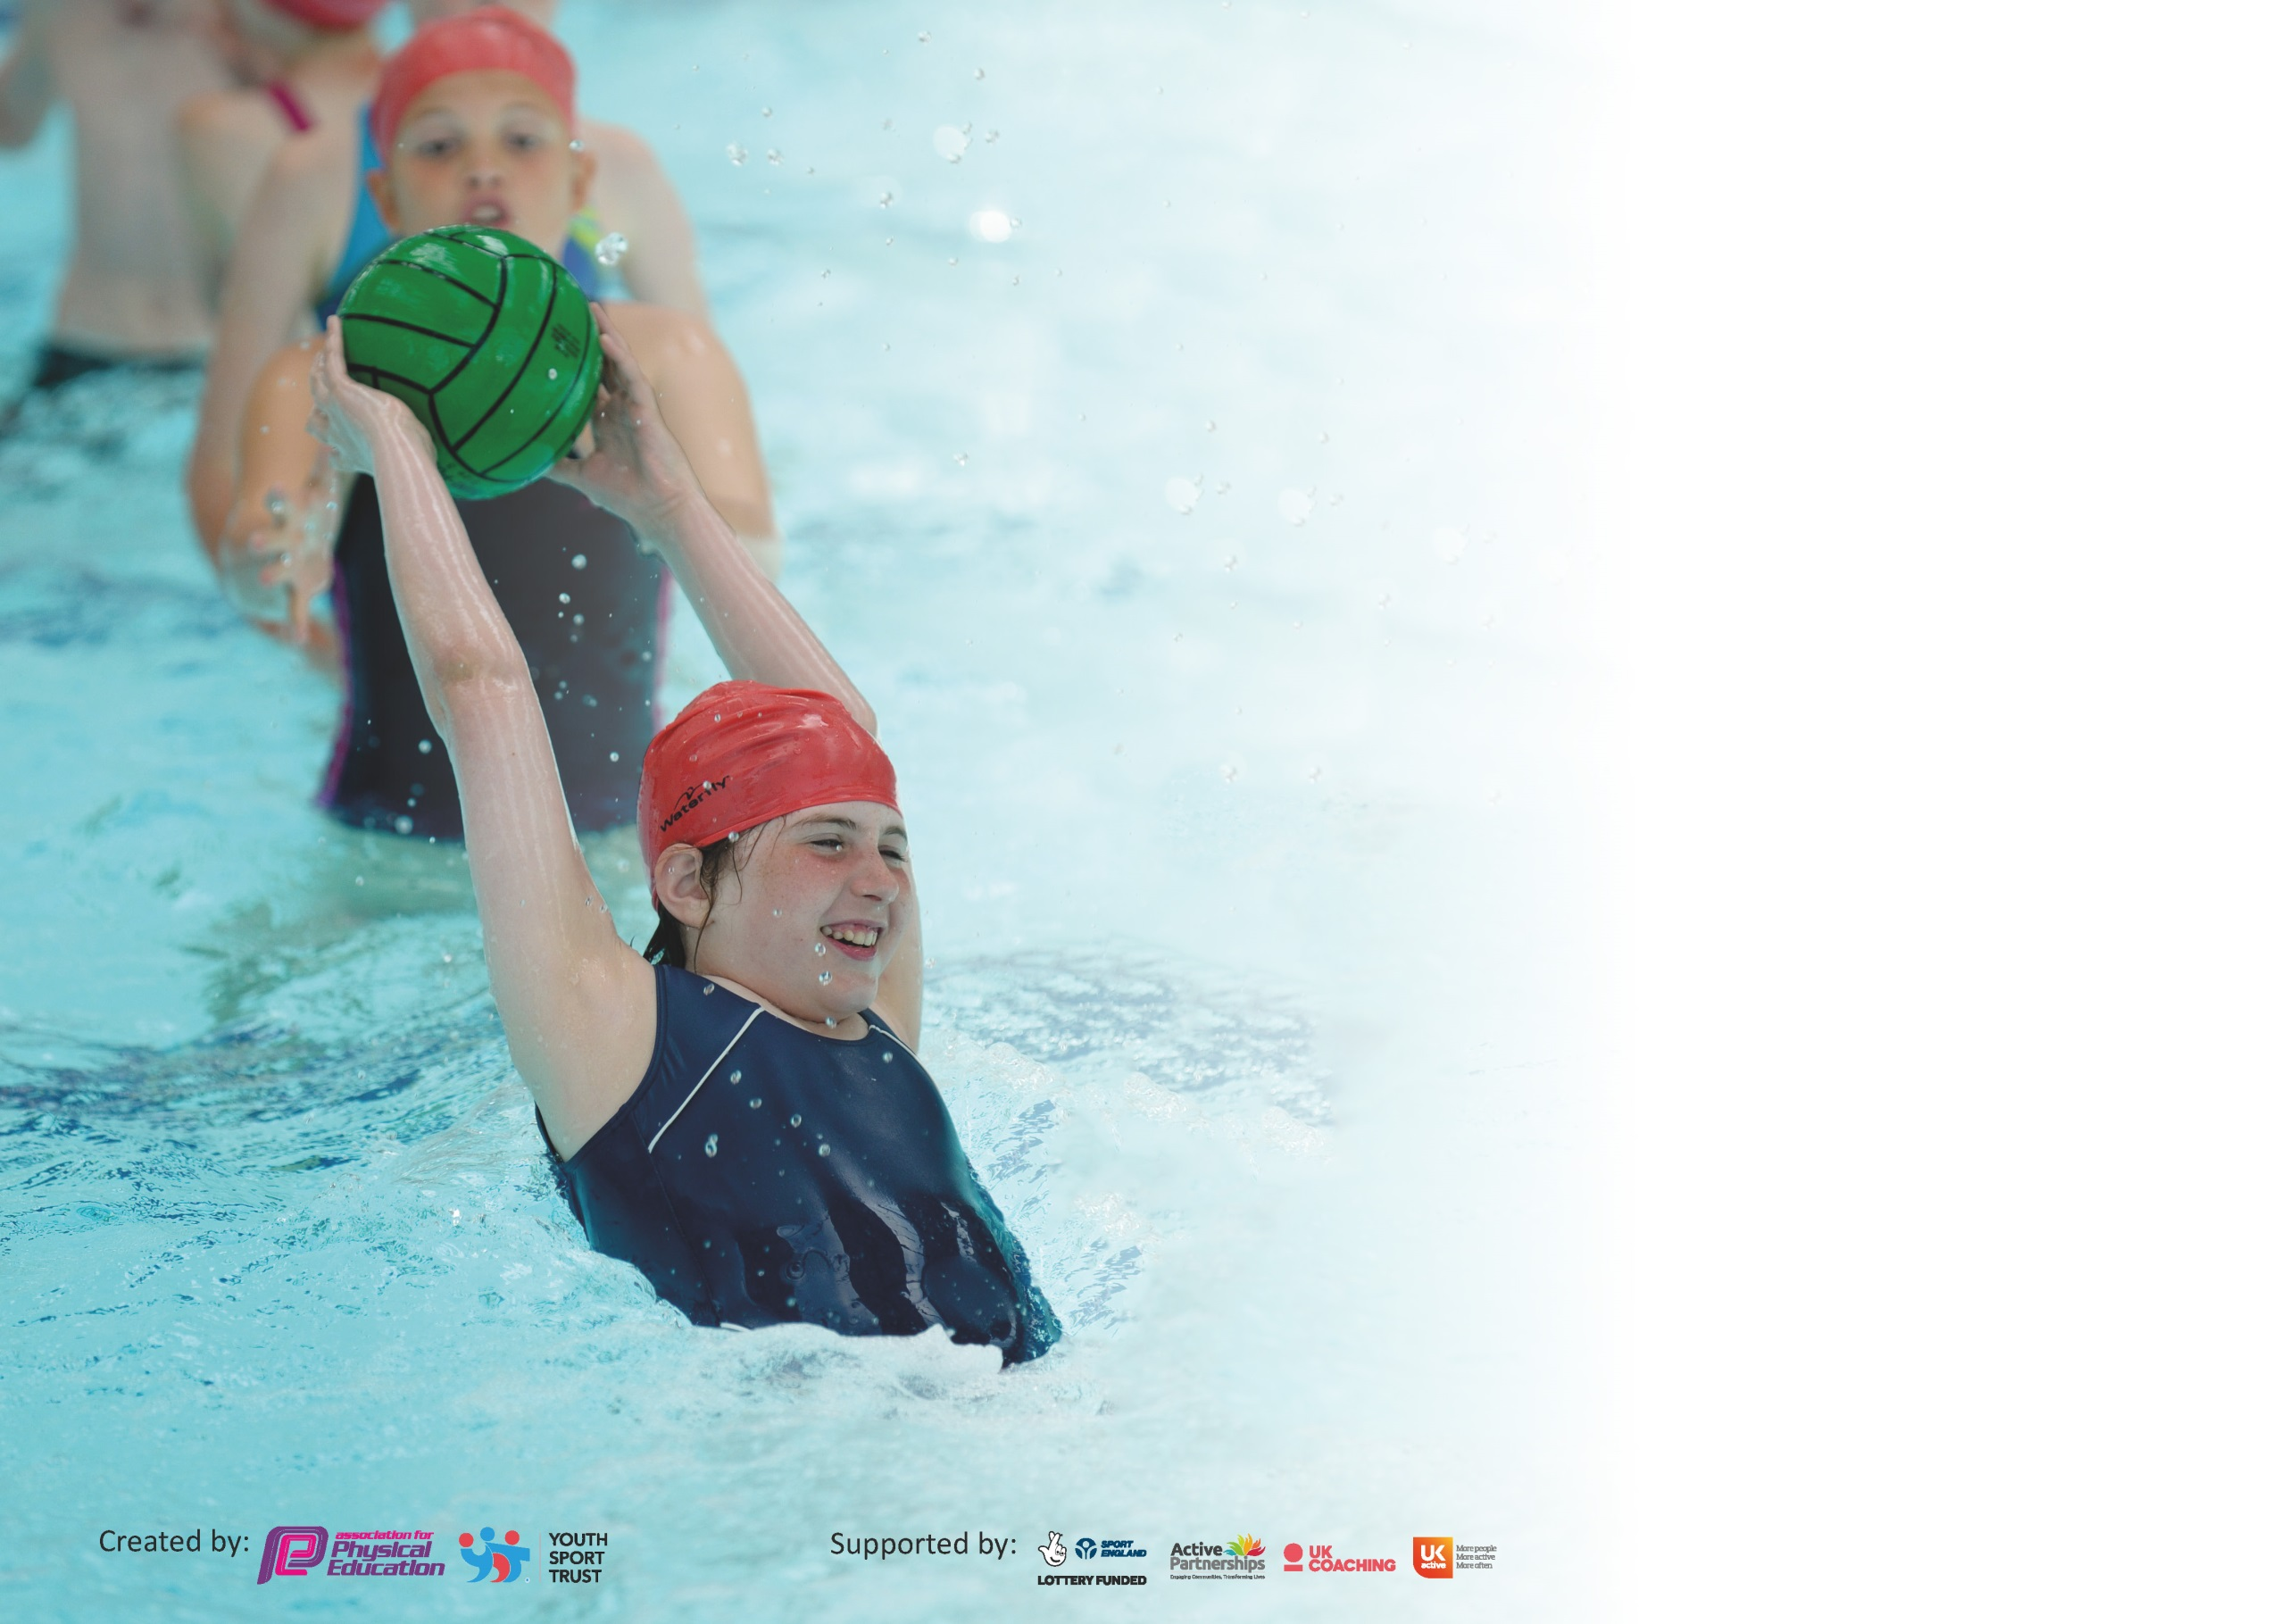

It is important that your grant is used effectively and based on school need. The Education Inspection Framework (Ofsted 2019 p64) makes clear there will be a focus on ‘whether leaders and those responsible for governors all understand their respective roles and perform these in a way that enhances the effectiveness of the school’.

Under the Quality of Education criteria (p41) inspectors consider the extent to which schools can articulate their curriculum (INTENT), construct their curriculum (IMPLEMENTATION) and demonstrate the outcomes which result (IMPACT).

To assist schools with common transferable language this template has been developed to utilise the same three headings which should make your plans easily transferable between working documents.

Schools must use the funding to make additional and sustainable improvements to the quality of Physical Education, School Sport and Physical Activity (PESSPA) they offer. This means that you should
use the Primary PE and Sport Premium to:

- Develop or add to the PESSPA activities that your school already offer
- Build capacity and capability within the school to ensure that improvements made now will benefit pupils joining the school in future years

Please visit gov.uk for the revised DfE guidance including the 5 key indicators across which schools should demonstrate an improvement. This document will help you to review your provision and to report your spend. DfE encourages schools to use this template as an effective way of meeting the reporting requirements of the Primary PE and Sport Premium.

We recommend you start by reflecting on the impact of current provision and reviewing the previous spend.

Schools are required to publish details of how they spend this funding as well as on the impact it has on pupils’ PE and sport participation and attainment by the end of the summer term or by 31st July 2020 at the latest.

We recommend regularly updating the table and publishing it on your website throughout the year. This evidences your ongoing self-evaluation of how you are using the funding to secure maximum, sustainable impact. Final copy must be posted on your website by the end of the academic year and no later than the 31st July 2020. To see an example of how to complete the table please click HERE.

Support for review and reflection - considering the 5 key indicators from DfE, what development needs are a priority for your setting and your pupils now and why? Use the space below to reflect on previous spend and key achievements and areas for development.

Key achievements to date until July 2019: | Areas for further improvement and baseline evidence of need:
Silver Games Mark achieved, after a moderation.  Virtual Sports Week, despite lockdown restraints.  Wellbeing time continued successfully.  Four after school sports clubs running at any time throughout the year. | Provision for lunch time – more equipment to encourage sports involvement.  Targeting exercise and wellbeing for all, after Covid-19 crisis.  Inclusion of all children.  2019-2020 Unspent Budget - £3529.25:  More equipment to help children adhere to social distancing in lessons and at lunchtimes.  Wellbeing techniques included – access to yoga/meditation videos.  Upgrade of playground – courts marked out clearly for sports competitions.  Daily mile track for children to help achieve 30 active minutes a day and encourage exercise during play times.

Meeting national curriculum requirements for swimming and water safety.
What percentage of your current Year 6 cohort swim competently, confidently and proficiently over a distance of at least 25 metres?  N.B. Even though your pupils may swim in another year please report on their attainment on leaving  primary school at the end of the summer term 2020. | 48.27%
What percentage of your current Year 6 cohort use a range of strokes effectively [for example, front crawl, backstroke and breaststroke]? | 48.27%
What percentage of your current Year 6 cohort perform safe self-rescue in different water-based situations? | 48.27%
Schools can choose to use the Primary PE and Sport Premium to provide additional provision for swimming but this must be for activity over and above the national curriculum requirements. Have you used it in this way? | Yes/No

Action Plan and Budget Tracking
Capture your intended annual spend against the 5 key indicators. Clarify the success criteria and evidence of impact that you intend to measure to evaluate for pupils today and for the future.

Academic Year: 2019/20 | Total fund allocated: £19,530 | Date Updated:17.07.2020
Key indicator 1: The engagement of all pupils in regular physical activity – Chief Medical Officer guidelines recommend that primary school pupils undertake at least 30 minutes of physical activity a day in school |  |  |  | Percentage of total allocation:
 |  |  |  | 59.62%
Intent | Implementation |  | Impact
Your school focus should be clear what you want the pupils to know and be able to do and about  what they need to learn and to  consolidate through practice: | Make sure your actions to achieve are linked to your intentions: | Funding allocated: | Evidence of impact: what do pupils now know and what can they now do? What has changed?: | Sustainability and suggested next steps:
The engagement of children who are less active during their lunch hour and providing a wide variety of after-school clubs. | Coaches to promote their daily activities.  Coaches to promote their after-school clubs in assemblies. | £11,645 | Children have a higher level of excitement and appreciation for sports throughout school.  More children taking part in lunchtime activity. | Continuation of lunch time coaches.  Coaches to now incorporate house matches to increase the participation levels of all groups.
Key indicator 2: The profile of PESSPA being raised across the school as a tool for whole school improvement |  |  |  | Percentage of total allocation:
 |  |  |  | 22.30%
Intent | Implementation |  | Impact
Your school focus should be clear what you want the pupils to know and be able to do and about  what they need to learn and to  consolidate through practice: | Make sure your actions to achieve are linked to your intentions: | Funding allocated: | Evidence of impact: what do pupils now know and what can they now do? What has changed?: | Sustainability and suggested next steps:
Updating equipment available to children during their lesson times. Allows children to have a wider range of sports available to them.  Video system to target the teaching of dance, and make it more accessible to all.  The use of a TLR to PE Leader, to promote an ethos of sport, well-being and competition. | Equipment to be audited and see where there are gaps in our provision.  Audit of teacher’s confidence in teaching dance, helping to promote well-being.  Development of Sports Council, Play Leaders, entering competitions and after-school clubs. | £4355.75 | From an audit of what we currently have, and Sports Council suggestions, we bought more equipment which the children found most necessary.  Developing the dance curriculum to appeal to a wider range of children.  Sports Council set-up and developing, allowing a pupil voice to sports.  Play Leaders trained. | Use the equipment during lunch times, competitions and after school clubs to promote PESSPA further.  Focus on competitions, allowing more non-curriculum practise.  Well-being techniques set up through yoga teaching.

Key indicator 3: Increased confidence, knowledge and skills of all staff in teaching PE and sport |  |  |  | Percentage of total allocation:
 |  |  |  | 0%
Intent | Implementation |  | Impact
Your school focus should be clear | Make sure your actions to | Funding | Evidence of impact: what do | Sustainability and suggested
what you want the pupils to know | achieve are linked to your | allocated: | pupils now know and what | next steps:
and be able to do and about | intentions: |  | can they now do? What has
what they need to learn and to |  |  | changed?:
consolidate through practice:
 |  |  |  | Look into possible CPD, if needed.
Key indicator 4: Broader experience of a range of sports and activities offered to all pupils |  |  |  | Percentage of total allocation:
 |  |  |  | 0%
Intent | Implementation |  | Impact
Your school focus should be clear | Make sure your actions to | Funding | Evidence of impact: what do | Sustainability and suggested
what you want the pupils to know | achieve are linked to your | allocated: | pupils now know and what | next steps:
and be able to do and about | intentions: |  | can they now do? What has
what they need to learn and to |  |  | changed?:
consolidate through practice:
Additional achievements: |  |  |  | When purchasing equipment, think about which new sports can be introduced.

Key indicator 5: Increased participation in competitive sport |  |  |  | Percentage of total allocation:
 |  |  |  | 0%
Intent | Implementation |  | Impact
Your school focus should be clear | Make sure your actions to | Funding | Evidence of impact: what do | Sustainability and suggested
what you want the pupils to know | achieve are linked to your | allocated: | pupils now know and what | next steps:
and be able to do and about | intentions: |  | can they now do? What has
what they need to learn and to |  |  | changed?:
consolidate through practice:
 |  |  |  | When competitions are able to take place, make sure we continue with our high participation rate.

Signed off by
Head Teacher:
Date:
Subject Leader: | Miss Sian Perry
Date: | 17.07.2020
Governor:
Date:

