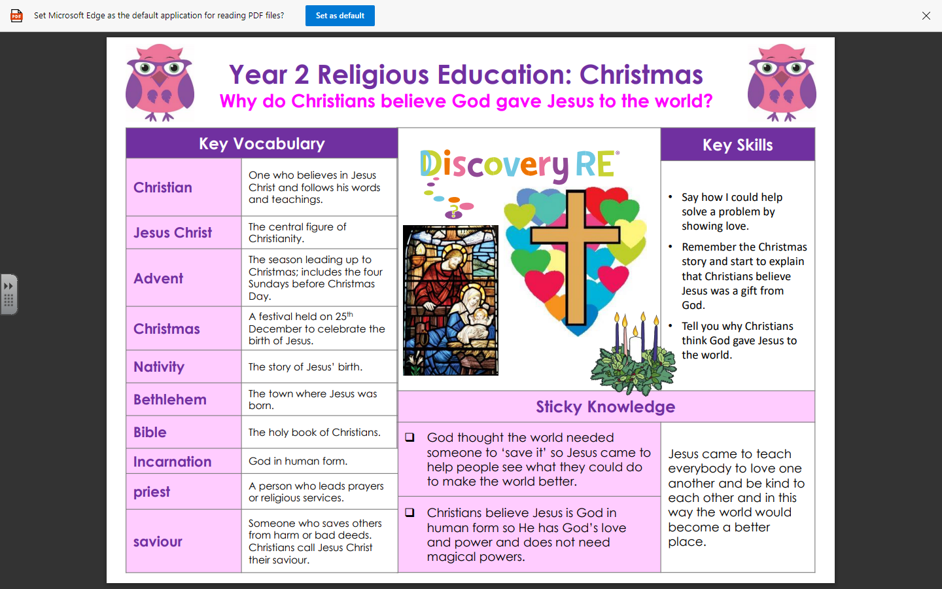

Golden Thread: Sustainability

RE – Unit 2 – Christianity: Why do Christians believe God gave Jesus to the world?
Working together to be the best that we can be
Autumn 2
Year 2

