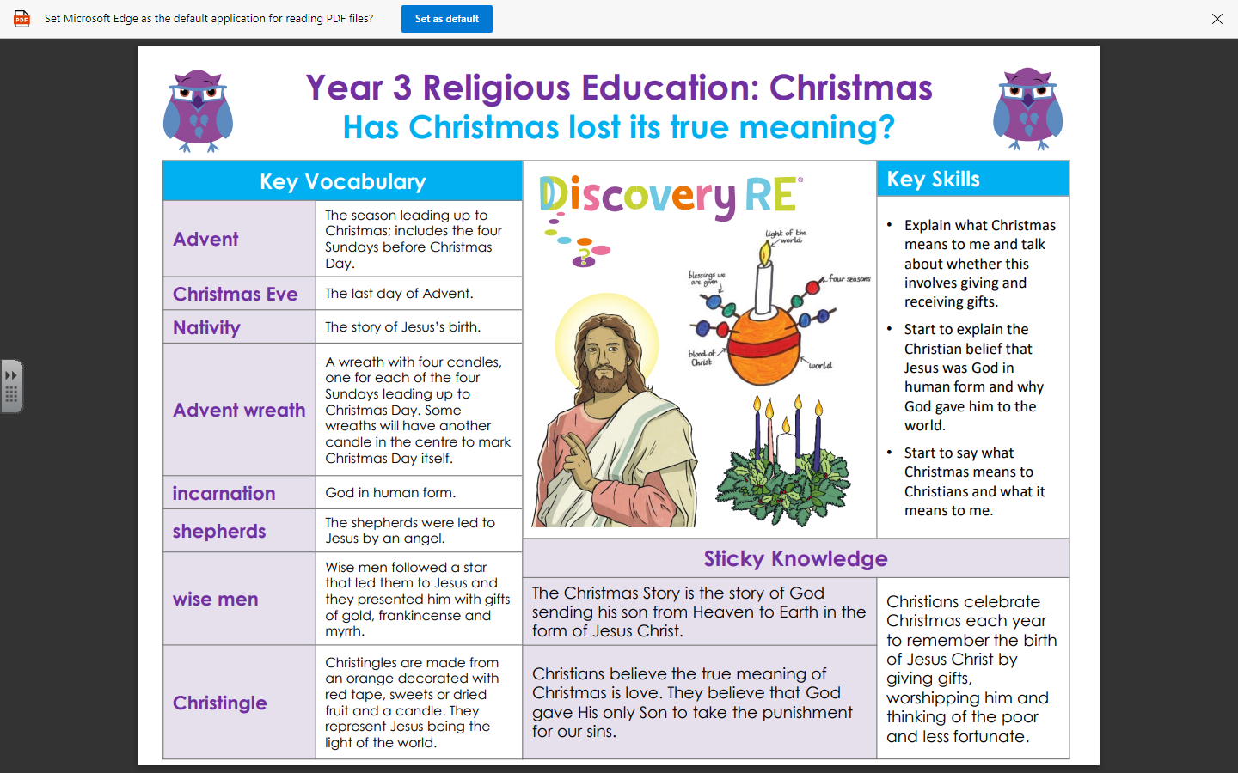

Golden Thread: Material Culture

RE – Unit 2 – Christianity: Has Christmas lost its true meaning?
Working together to be the best that we can be
Autumn 2
Year 3

