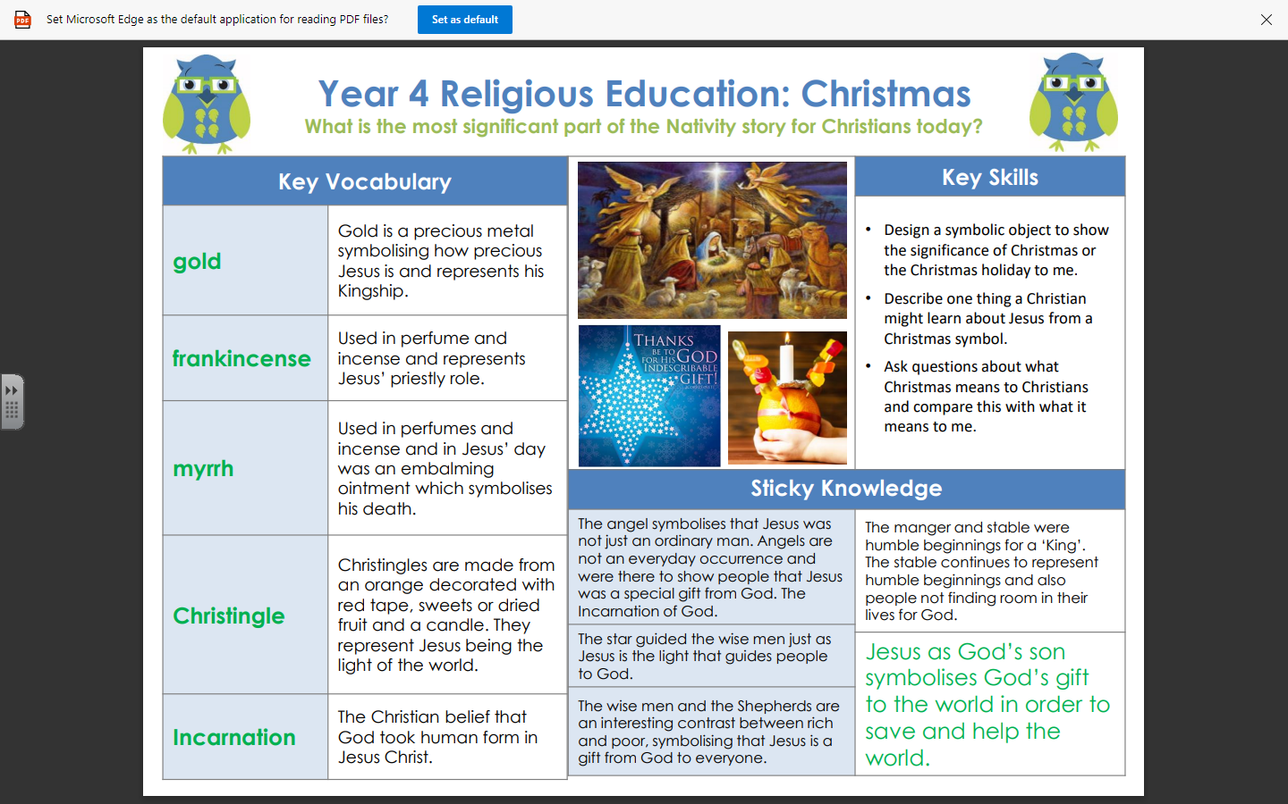

RE – Unit 2 – Christianity: What is the most significant part of the Nativity story for Christians today?

Working together to be the best that we can be
Golden Thread: Belonging

Autumn 2
Year 4

