
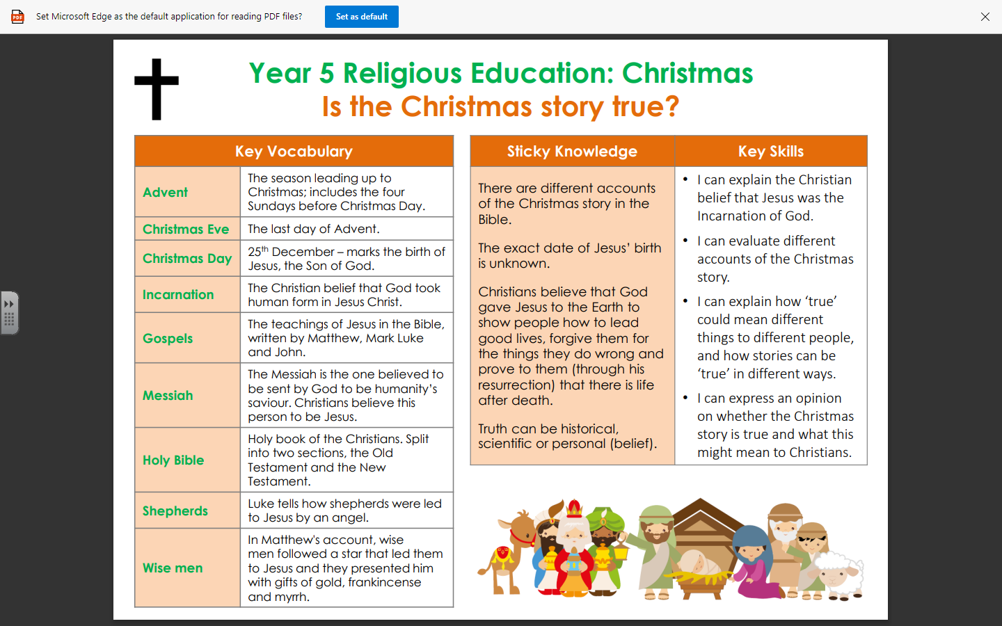

RE – Unit 2 – Christianity: Is the Christmas story true?

Working together to be the best that we can be
Golden Thread: Belonging

Autumn 2
Year 5

