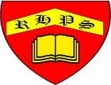
RE – Unit 2 – Christianity: How significant is it that Mary was Jesus’ mother?
Working together to be the best that we can be
Golden Thread: Belonging

Autumn 2
Year 6

