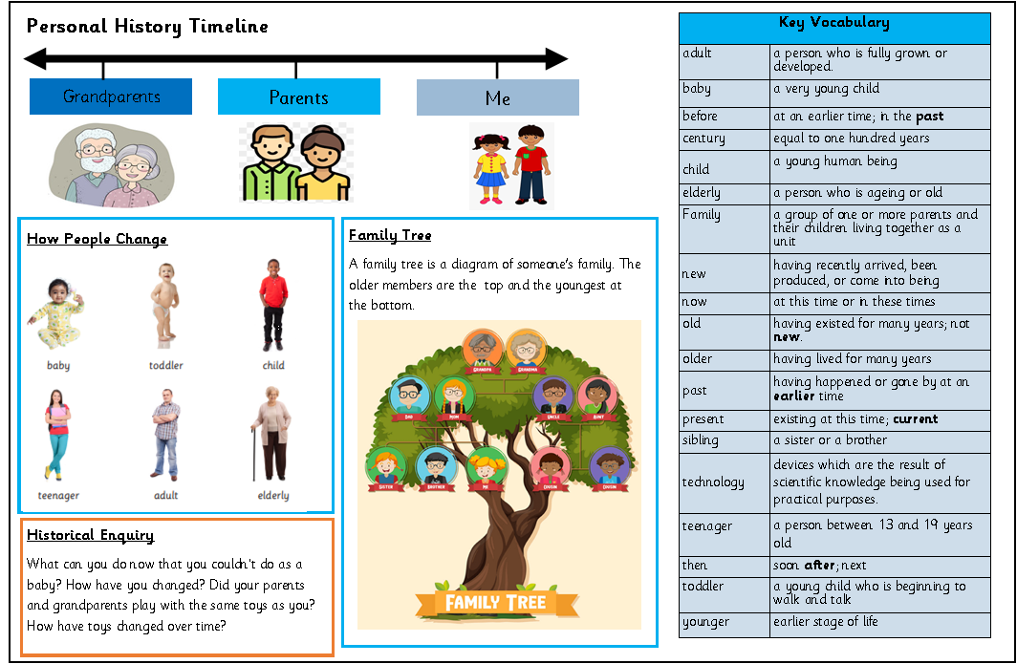

Golden Thread: Belonging
History- Unit 1- My Personal History
Autumn 2
Year 1
Working together to be the best that we can be
