
Golden Thread: Technological Advancement
History- Unit 1- The Great Fire of London
Autumn 2
Year 2
Working together to be the best that we can be
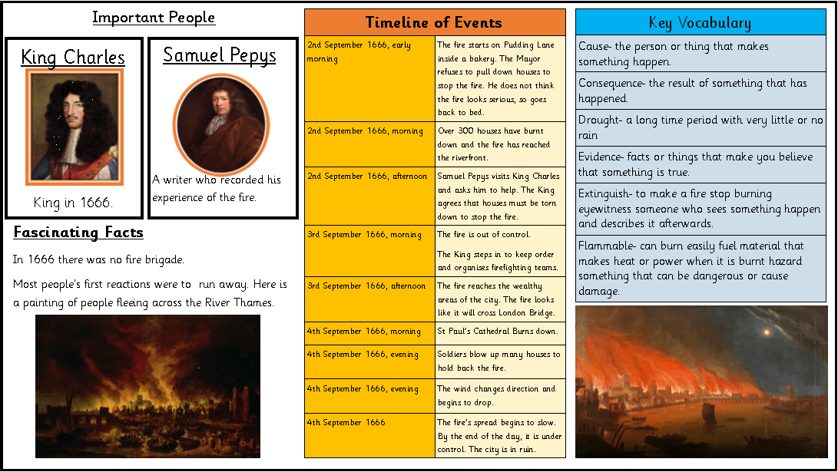

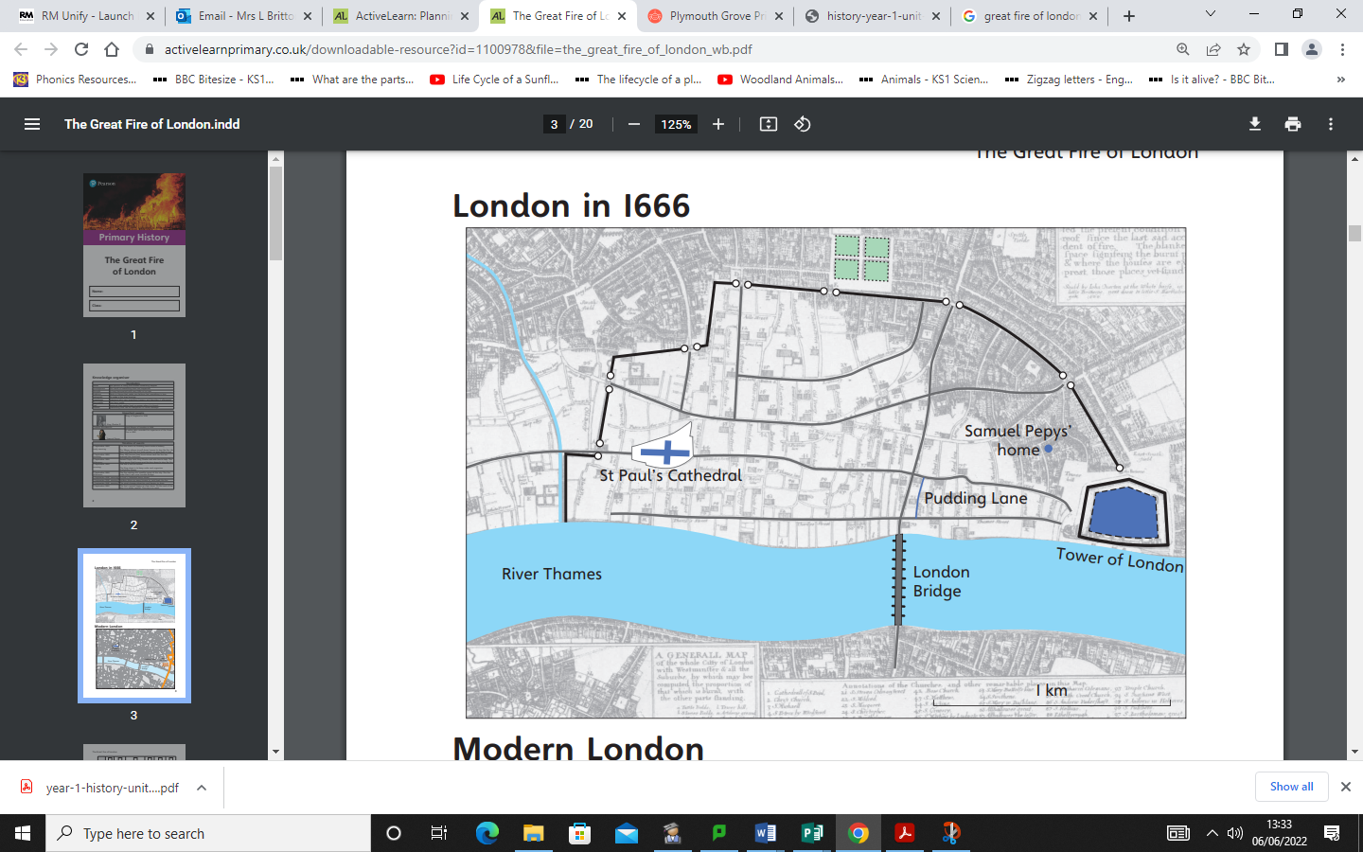
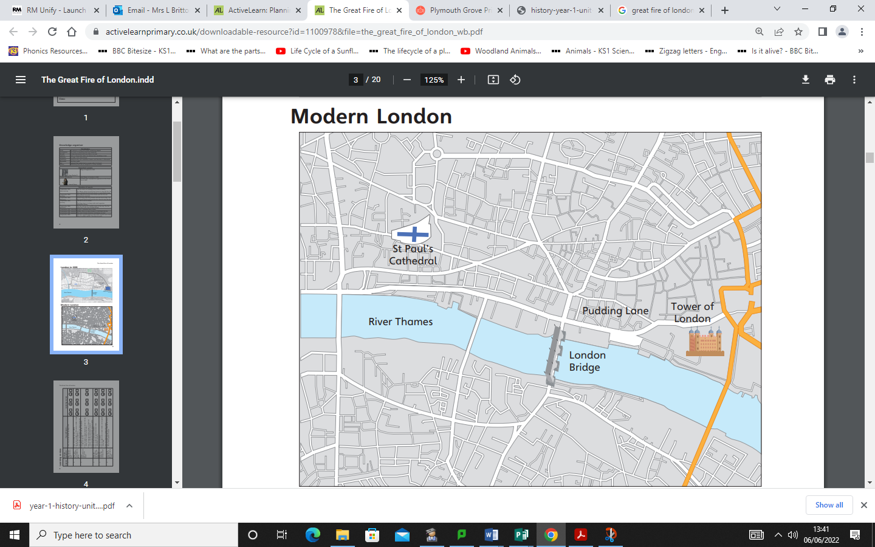
London in 1666
Modern London
Historical Enquiry
Why did the fire start? Where did the fire start? Why did the fire spread so quickly? How did the fire change the way houses were built? Why is the Samuel Pepys diary an important historical source?

