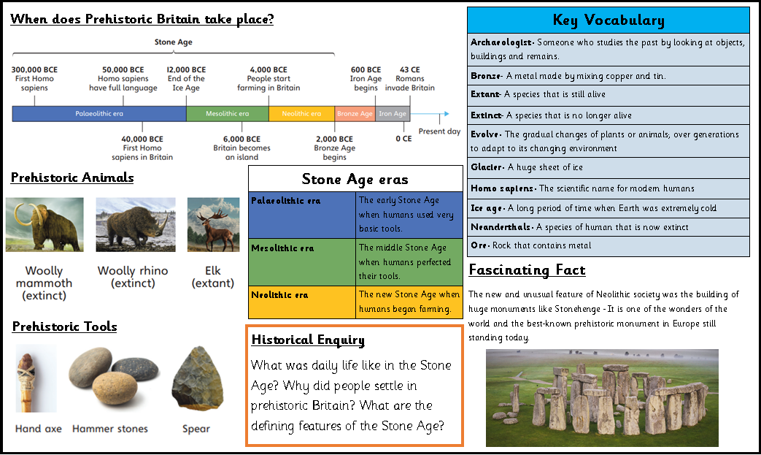
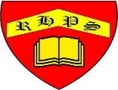
Golden Thread: Civilisations
History- Unit 1- Prehistoric Britain
Autumn 2
Year 3
Working together to be the best that we can be

