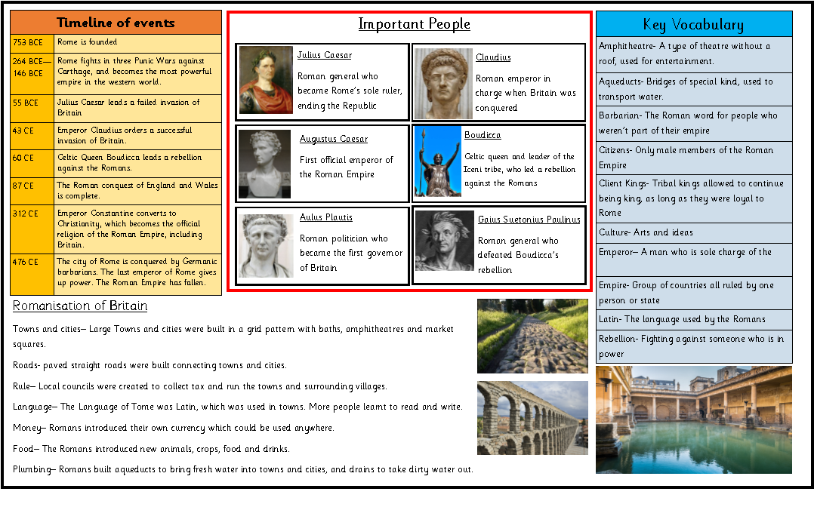

Golden Thread: Civilisations
History- Unit 1- Roman Britain
Autumn 2
Year 4
Working together to be the best that we can be

