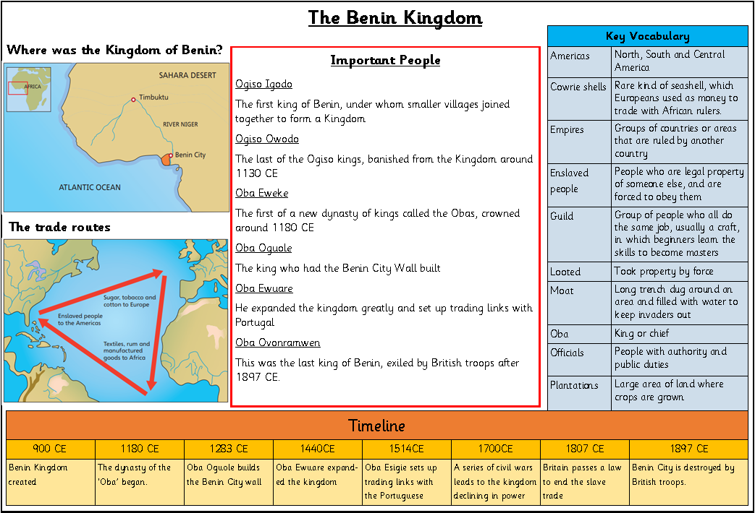
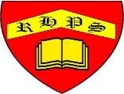
Golden Thread: Civilisations
History- Unit 1- Benin Kingdom
Autumn 2
Year 5
Working together to be the best that we can be
