
Golden Thread: Belonging
English – Unit 2: What skills make me a writer?
Autumn 2
Year 2
Working together to be the best that we can be
Nouns
Naming words
Proper – names and places begins with a capital letter eg. England
Abstract – thoughts or feelings eg. happiness
Concrete – things you can touch eg. table


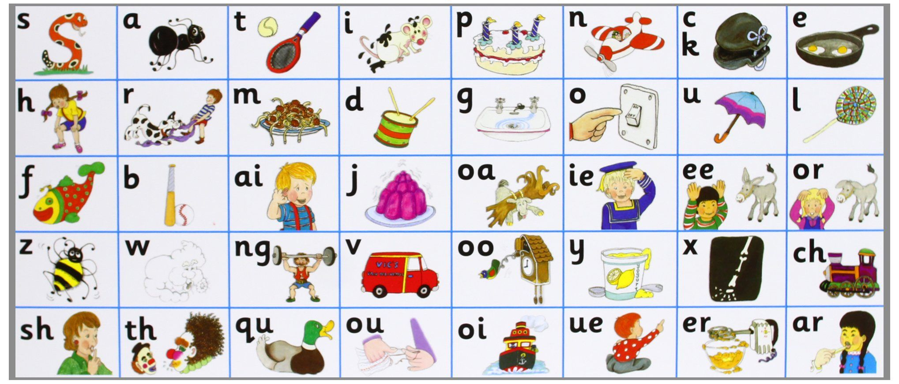


Don’t forget your finger spaces!
separate extra information in a sentence
shows exclamations, commands, or strong emotions
used to join words or add a prefix
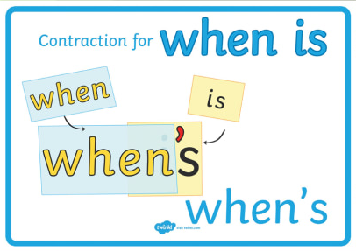
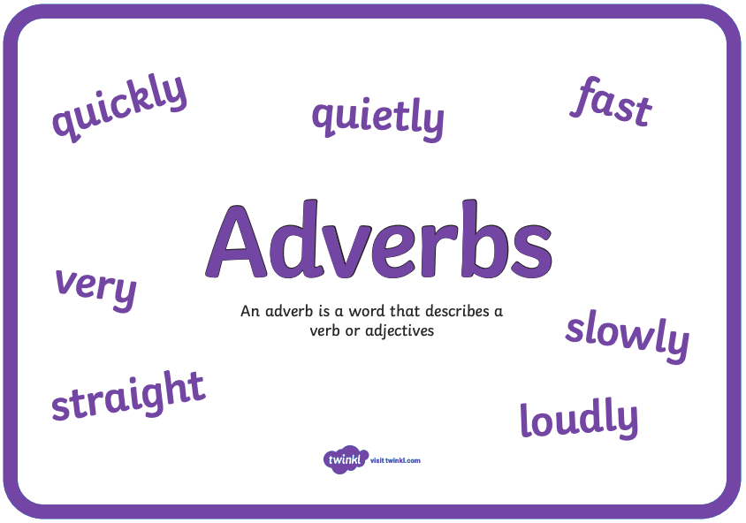
shows direct speech
Commas for lists
,
We use a comma to separate items in a list!
Example:
I have a cat, dog, bird and fish.

used to join clauses and separate long lists
adds tension by creating a pause

