
Golden Thread: Belonging
English – Unit 1: What skills make me a writer?
Autumn 2
Year 3
Working together to be the best that we can be
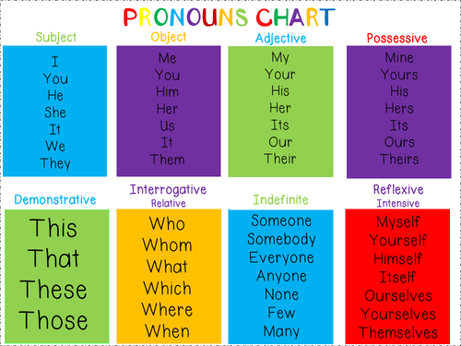

Noun Phrase
Contains a noun and modifiers about the noun eg.
The small, yellow car

Nouns
Naming words
Proper – names and places begins with a capital letter eg. England
Abstract – thoughts or feelings eg. happiness
Concrete – things you can touch eg. table

Vowels
a e i o u
If the word after begins with a vowel, use ‘an’

Verbs – action words
Adverbs – describes the action
Adjectives – describing words

‘ apostrophe
, commas

! exclamation
marks
“” inverted
commas

shows missing letters and possession
used in lists, to join clauses, and separate extra information

shows exclamations, commands, or strong emotions

shows direct speech

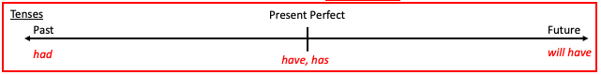

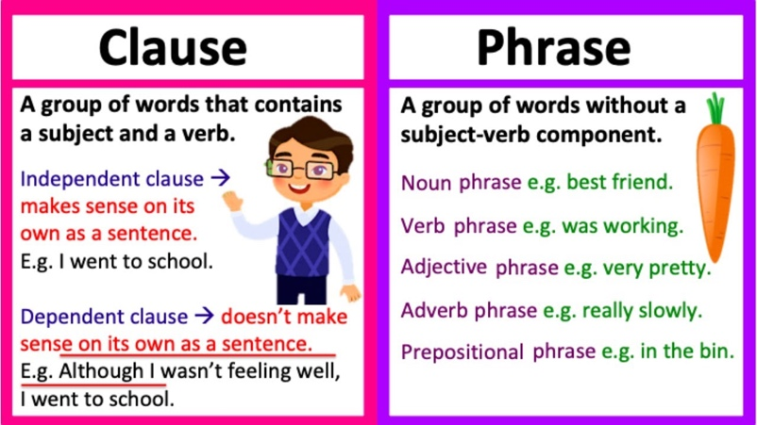
determiner
adverb
verb
noun
preposition
Can I identify the word classes of a simple sentence?

The young boy ran quickly to the party.
adjective

