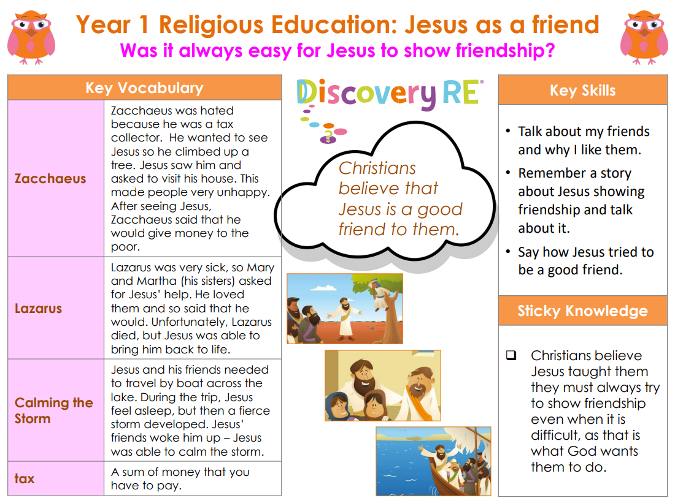

**RE – Unit 2 – Christianity:** Was it always easy for Jesus to show friendship?

**Working together to be the best that we can be**



**Golden Thread: Belonging**



Spring 1

Year 1