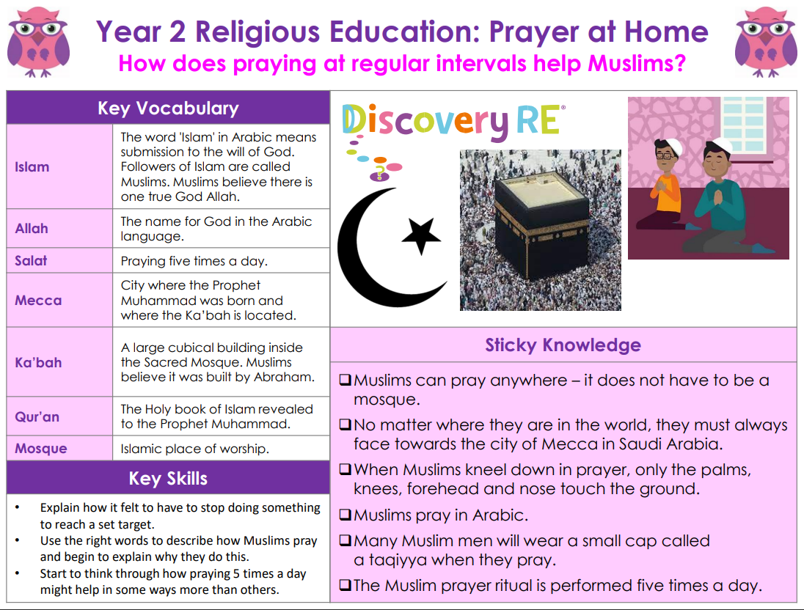

**RE – Unit 2 – Islam:** How does praying at regular intervals help Muslims?

**Working together to be the best that we can be**



**Golden Thread: Belonging**



Spring 1

Year 2