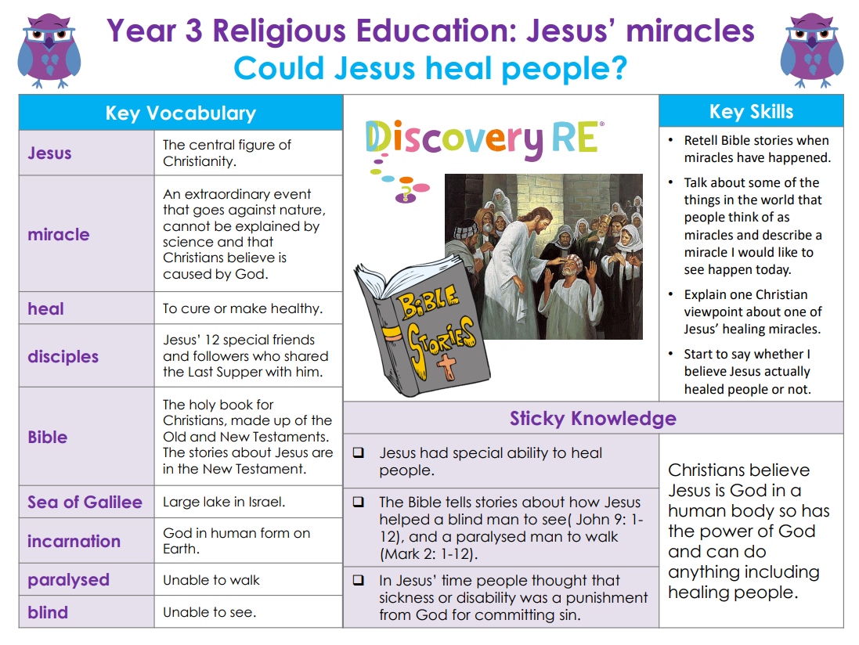

**RE – Unit 3 – Christianity:** Could Jesus heal people?

**Working together to be the best that we can be**



**Golden Thread: Belonging**



Spring 1

Year 3