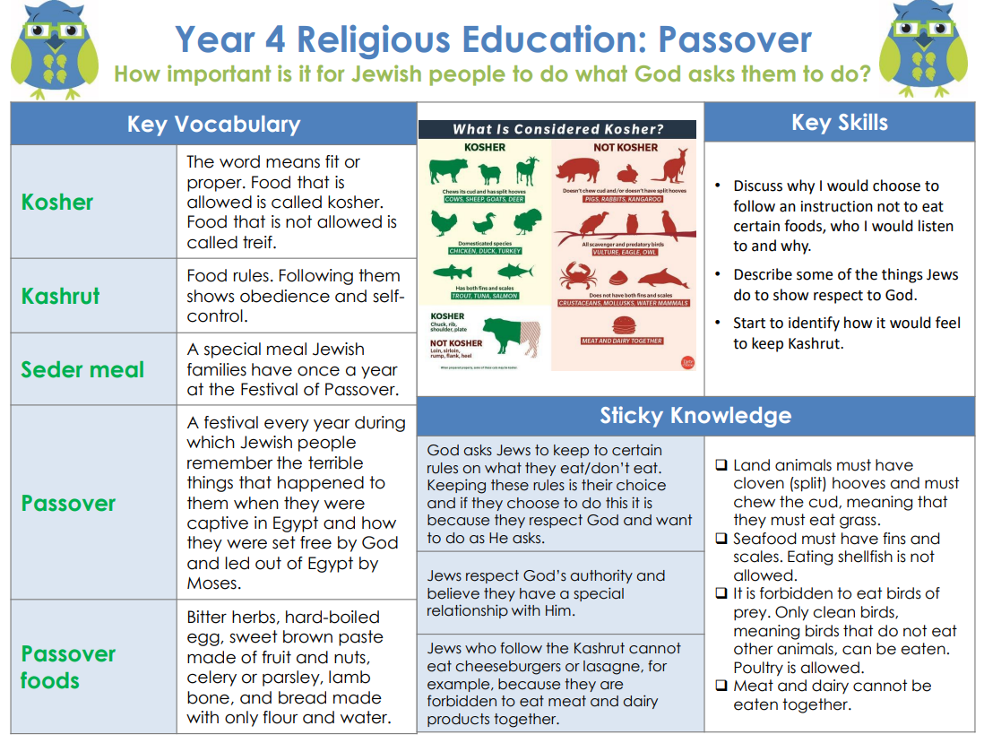

**RE – Unit 3 – Judaism:** How important is it for Jewish people to do what God asks them to do?

**Working together to be the best that we can be**



**Golden Thread: Sustainability**



Spring 1

Year 4