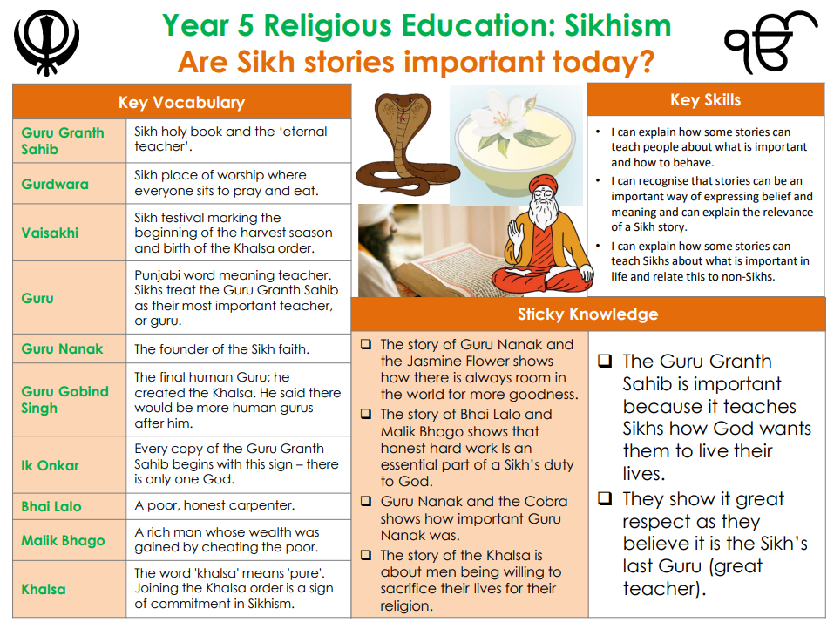

**RE – Unit 3 – Sikhism:** Are Sikh stories important today?

**Working together to be the best that we can be**



**Golden Thread: Belonging**



Spring 1

Year 5