**RE – Unit 3 – Christianity:** Is anything ever eternal?

**Working together to be the best that we can be**

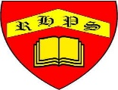

**Golden Thread: Sustainability**



Spring 1

Year 6

