**Golden Thread: Sustainability/Belonging**

**Geography – Unit 1 – Hot and cold places**

Spring 1

Year 1

**Working together to be the best that we can be**



Animals have adapted to live in different places. Some animals live in hot places and some animals live on cold places. Animals have different features to allow them to live in their environment.

Temperatures vary in different locations.

This can be different temperatures in one place, like school, or different temperatures that occur around the world.

Some places can be hot, and some places can be cold.

**Talking Points**

What do hot and cold places feel like?

Where can you find hot and cold places on Earth?

How does the temperature affect hot or cold places?

What features does an animal need to live in a hot or cold place?

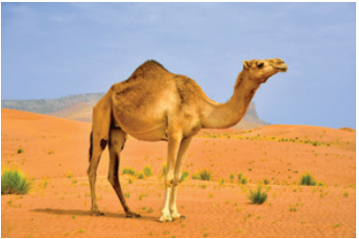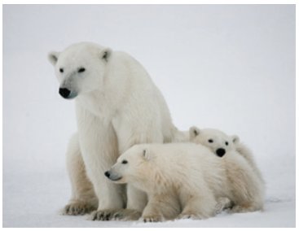

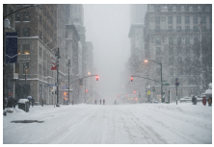

**Key vocabulary**

Atlas - book of maps

Climate - what the weather is usually like, e.g. it is usually hot in summer, cold in winter

Continent - large area of land, often with more than one country in it

Degrees Celsius - measurement of temperature

Globe - model of Earth

Location - a specific place

Temperature - how hot or cold something is

Thermometer - something used to measure temperature

Weather - what it is like outside today, e.g. is it raining or sunny?

Polar bears have thick fur to keep them warm in the cold Artic.

Camels have humps to store food and water in to help them to survive in the desert.

Hot

Cold

Places are colder the further away from the equator they are, and hotter the closer they are to the equator.