**Golden Thread: Belonging**

**English – Unit 3:** How can I develop my writing skills?

Spring 1

Year 1

**Working together to be the best that we can be**



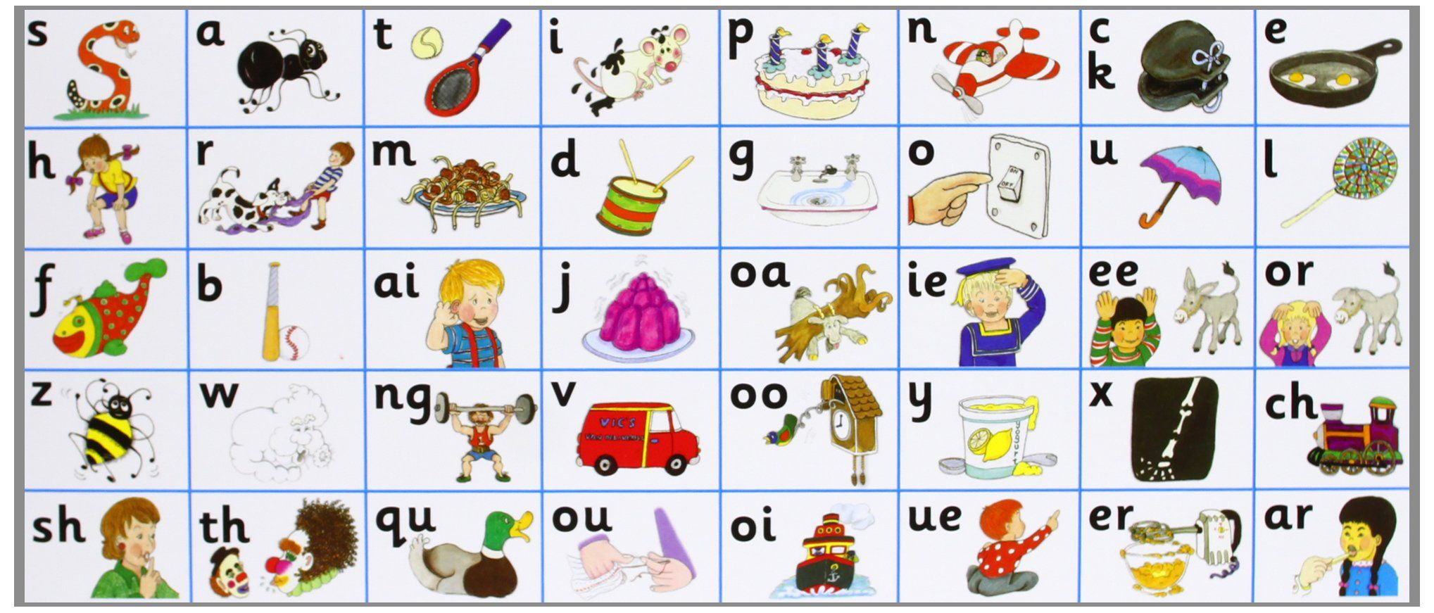



*separate extra information in a sentence*

*shows exclamations, commands, or strong emotions*

*used to join words or add a prefix*

Don’t forget your finger spaces!

*shows direct speech*

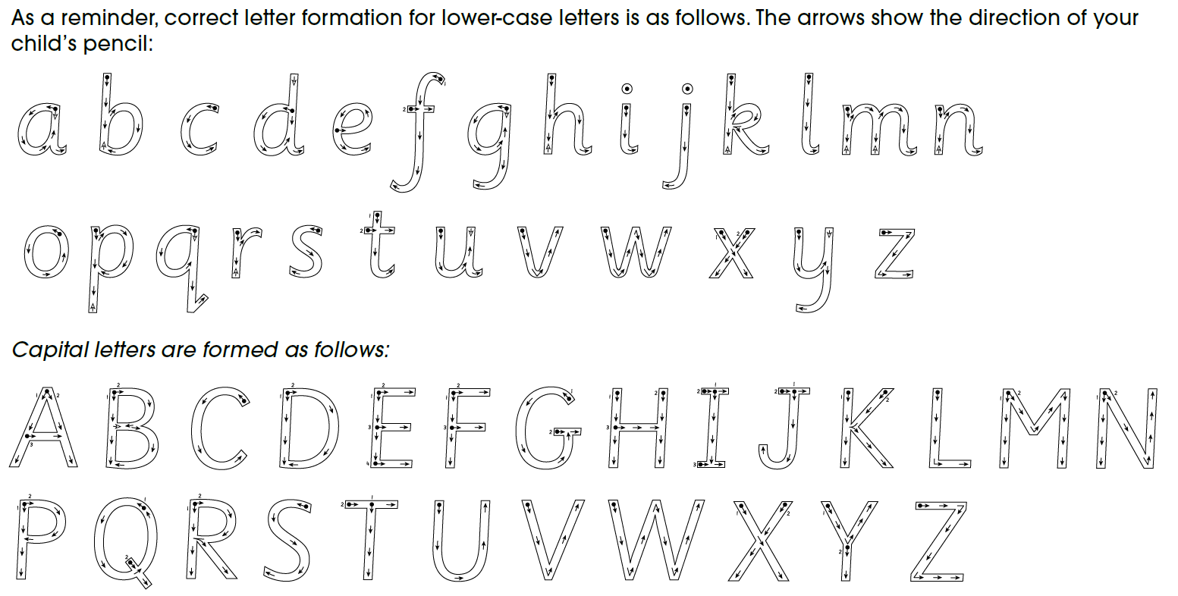

*used to join clauses and separate long lists*

*adds tension by creating a pause*