### **Charlie French**

### ***“I embrace a blank canvas with a sense of wonder and adventure.”***

### Charlie French is an abstract painter, living in London.

**Working together to be the best that we can be**

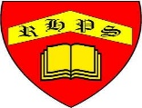

**Art – Paint, Texture and Colour – Expressive Painting**

Spring 1

Year 2

**Golden Thread: Material Culture**

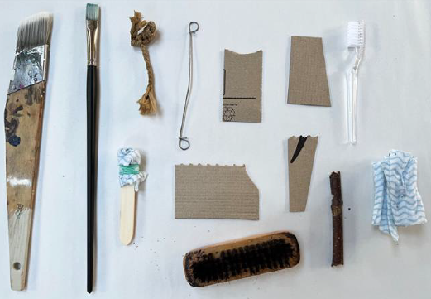

**Which home made tool inspires you?**

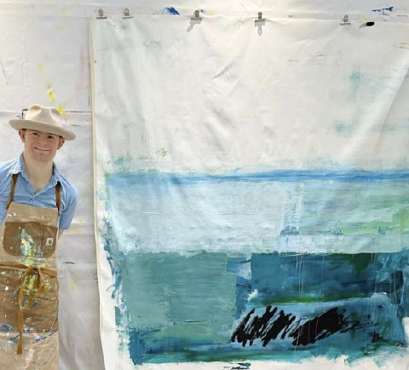

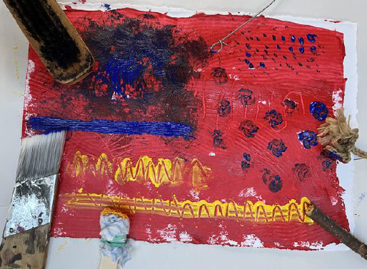

**Vocabulary**

**Mark making**

**Exploration**

**Imagination**

**Impression**

**Colour**

**Shape**

**Form**

**Texture**

**Line**

**Primary Colours (Red, Yellow, Blue)**

**Secondary Colours (Green, Purple, Orange)**

**Tints**

**Hues**

**Medium**

**Brush**

**Mark making Tools**

**Home-Made Tools**

**Abstract, Explore, Invent, Discover, Reflect,**

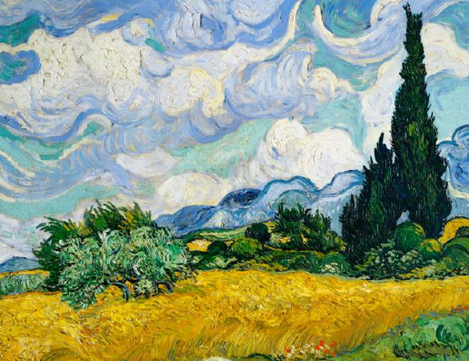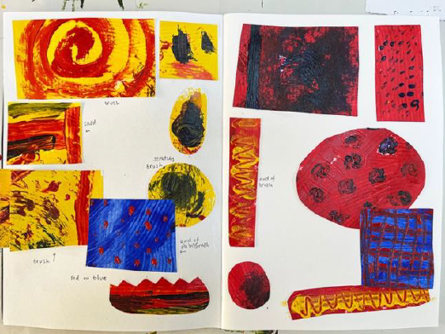

#### **Vincent van Gogh** was born March 30, 1853 in the Netherlands. **The painting below is known as the ‘Wheat Field with Cypresses**’ (1889).

**What colours can you see?**