Spring 1

**Year 2**

**Geography – Unit 1 – Polar Regions (North and South)**

**Golden Thread: Sustainability**

**Working together to be the best that we can be**

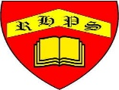

**Talking Points**

**Key vocabulary**

