**Golden Thread: Belonging**

**English – Unit 3:** How can I develop my writing skills?

Spring 1

Year 2

**Working together to be the best that we can be**



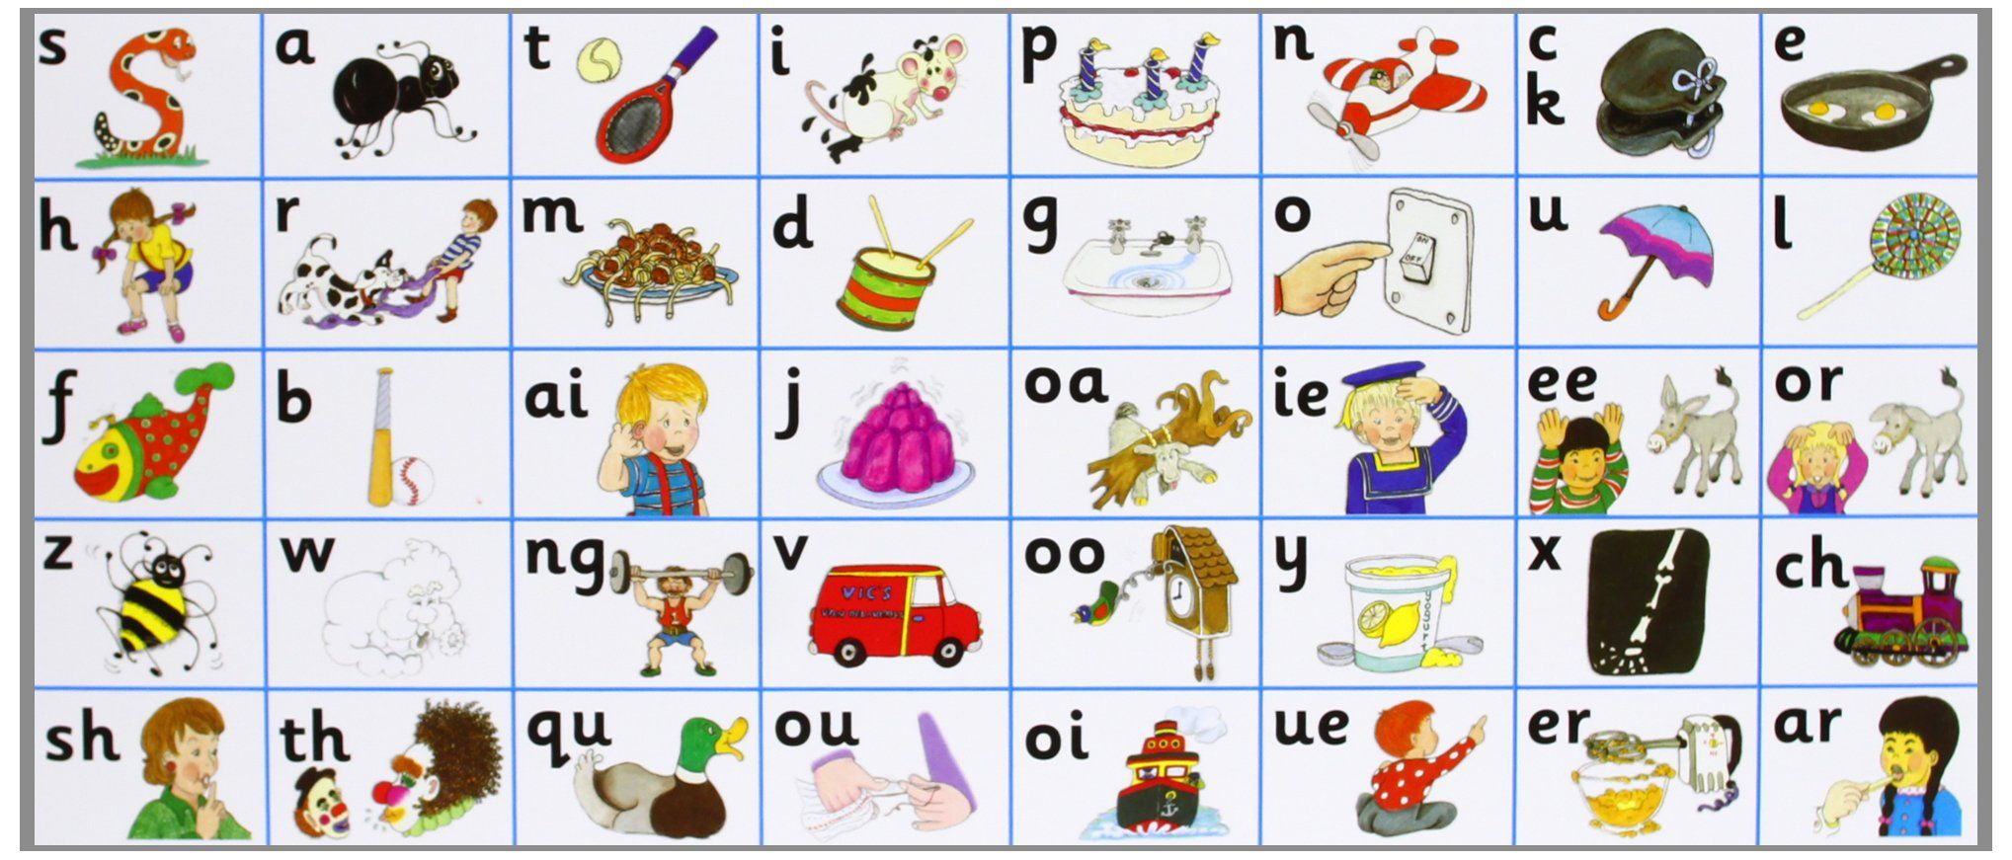

Don’t forget your finger spaces!

*separate extra information in a sentence*

*shows exclamations, commands, or strong emotions*

*used to join words or add a prefix*

*shows direct speech*

**Past Tense**

When we write in past tense, we talk about things that happened before.

We **walked** to the park.

Most verbs will end in -ed

*walked, danced, hopped, skipped, jogged*

*ran*

**Suffixes**

Suffixes come at the end of a root word. Here are some examples:

-ment

-ness

-full

-ly

***quietness***

*used to join clauses and separate long lists*

*adds tension by creating a pause*