**Working together to be the best that we can be**

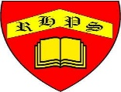

**Art – Working with Shape and Colour - Print, Colour, Collage**

Spring 2

Year 3

**Golden Thread: Material Culture**

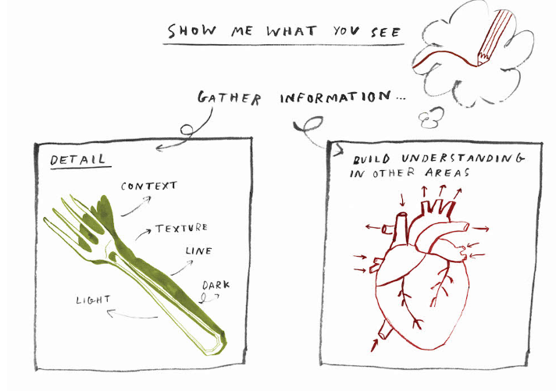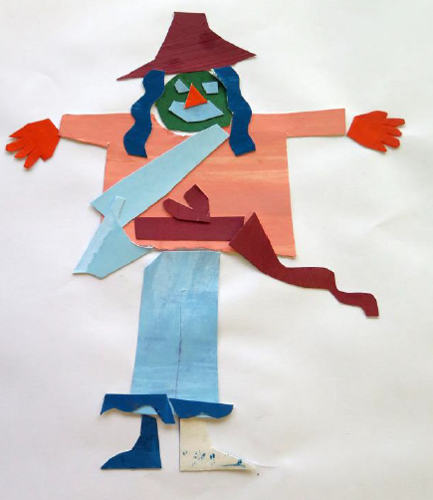

**Sketch**

**Note**

**Line**

**Shape**

**Capture**

**Share**

**Cut**

**Explore**

**Colour**

**Elements**

**Composition**

**Negative**

**Positive**

**Photograph**

**Composition**

**Lighting**

**Focus**

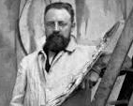

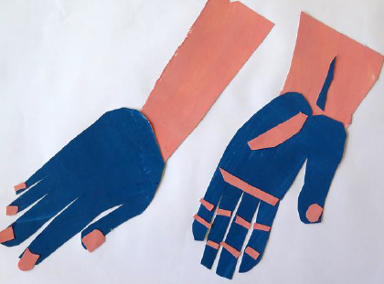

Opportunity to explore artwork using the ‘Show Me What You See’ technique.

**Henri** Émile Benoît **Matisse** was a French visual artist, known for both his use of colour and his fluid and original draughtsmanship.

****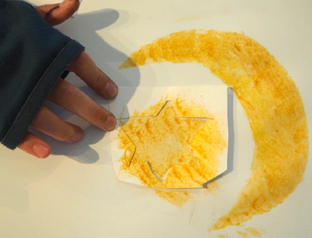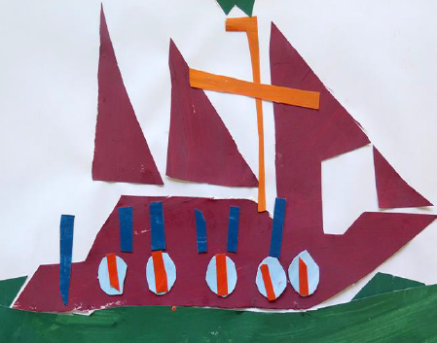

“Drawing With Scissors”