**Golden Thread: Sustainability/Civilisations**

**Geography – Unit 1 – Mountains, Volcanoes and Earthquakes**

Spring 1

Year 3

**Working together to be the best that we can be**

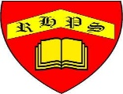

**Talking Points**

What is the Earth made of?

How are mountains and volcanoes formed?

How do earthquakes and volcanic eruptions happen?

Do the benefits of living near a volcano outweigh the risks?

**Key vocabulary**

Epicentre - The point on the Earth’s surface directly above the focus. An earthquake is felt most strongly at the epicentre.

Focus - The point deep underground where an earthquake starts

Friction - A force between two things that are trying to move past each other

Lava - Magma that has reached the Earth’s surface

Magma - Molten (melted) rock beneath the Earth’s surface

Moment magnitude scale - A scale from 1–10 to measure the strength of earthquakes

Pressure - A physical force created when solid things push against each other, or when gasses build up inside something and push against the sides

Seismic waves - Waves of energy created by an earthquake that travel through the Earth

Tectonic plates - Large sections, or plates, that make up the surface of the Earth

The Earth’s crust is made up of large pieces called tectonic plates, which move around on top of the mantle.

The plates move so slowly we do not notice it. Tectonic plates can be moving away from each other or moving towards each other.

The map below shows where volcanoes and earthquakes occur. What do you notice?

**Tectonic plates**

**Golden Thread: Sustainability/Civilisations**

**Working together to be the best that we can be**



**Geography – Unit 1 – Mountains, Volcanoes and Earthquakes**

Spring 1

Year 3

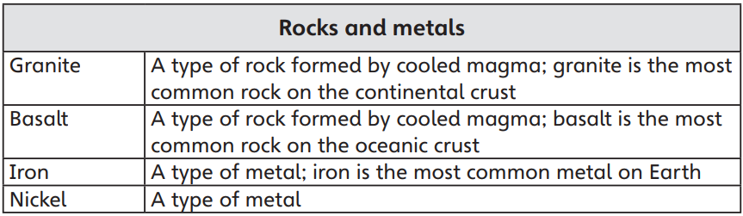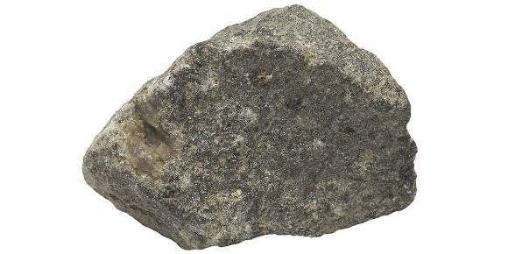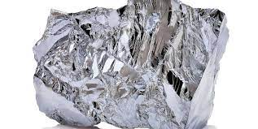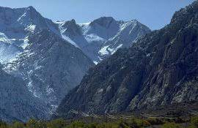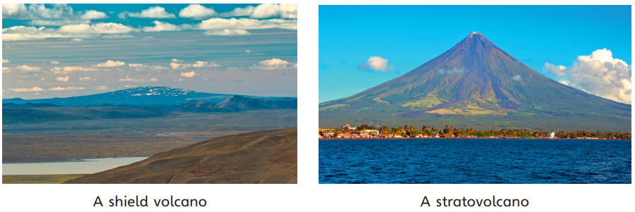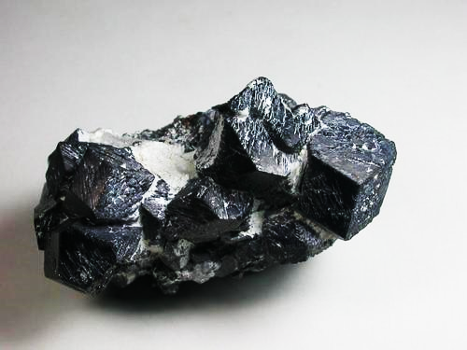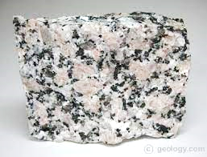

Fold mountain - A mountain created when two continental tectonic plates collide and cause the plates to wrinkle upwards.

Granite

Iron

Nickel

Basalt