**Golden Thread: Belonging**

**English – Unit 3:** How can I develop my writing skills?

Spring 1

Year 3

**Working together to be the best that we can be**



**Nouns**

**☺ Naming words ☺**

**Proper –** *names and places**begins with a capital letter eg. England*

**Abstract –** *thoughts or feelings eg. happiness*

**Concrete –** *things you can touch eg.* *table*

**Verbs –** *action words*

**Adverbs –** *describes the action*

**Adjectives –** *describing words*

**‘ apostrophe**

**, commas**

**! exclamation**

**marks**

**“” inverted**

**commas**

*shows missing letters and possession*

*used in lists, to join clauses, and separate extra information*

*shows exclamations, commands, or strong emotions*

*shows direct speech*

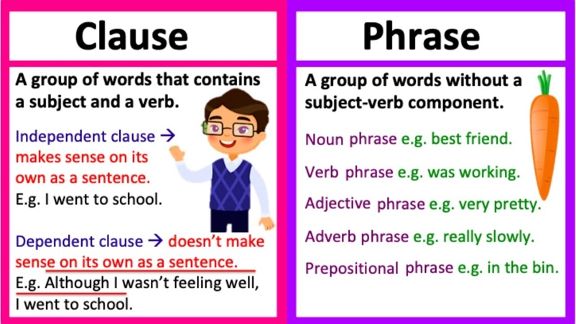

**determiner**

**adverb**

**verb**

**noun**

**preposition**

**Can I identify the word classes of a simple sentence?**

**The young boy ran quickly to the party.**

**adjective**