**Working together to be the best that we can be**



**Art – Paint, Texture, Surface – Exploring Still Life**

Spring 1

Year 4

**Golden Thread: Sustainability**

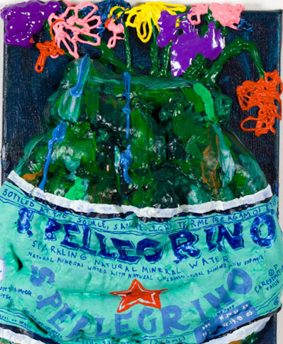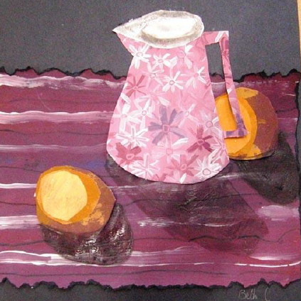

**When artists make work in response to static objects around them, it is called still life.**

**Still Life,**

**Genre,**

**Traditional,**

**Contemporary,**

**Composition,**

**Viewfinder,**

**Lighting,**

**Background,**

**Foreground,**

**Light,**

**Dark,**

**Tone,**

**Shadow,**

**Colour,**

**Hue,**

**Tint,**

**Elements,**

**Pattern,**

**Texture,**

**Colour,**

**2D,**

**3D,**

#### ****Palegrino****, Nicole Dyer, 2019, Acrylic, flashe, and insulation foam on canvas.

#### ****Still Life with a Skull and a Writing Quill****, Pieter Claesz (Dutch, Berchem? 1596/97–1660 Haarlem), 1628, Oil on wood

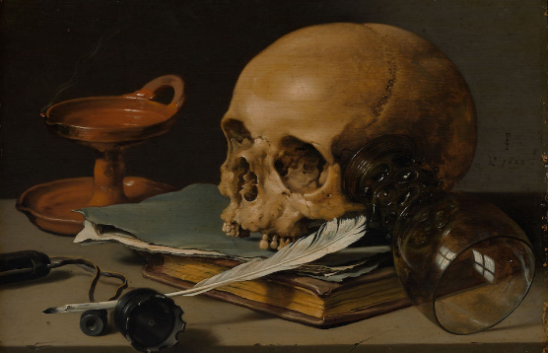

#### ****Close up of Flowers in a glass vase**** by Dutch painter Jan Davidsz. de Heem, 1606-1684.

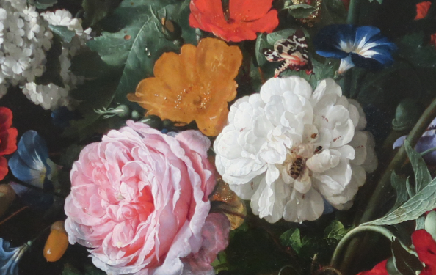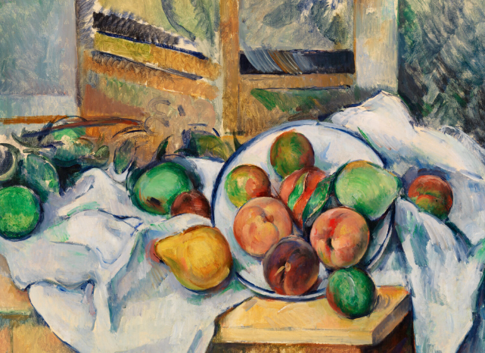

#### A Table Corner (Un coin de table) (1895) by Paul Cézanne.