**Geography – Unit 1 – Migration**

**Golden Thread: Sustainability**

Spring 1

Year 4

**Working together to be the best that we can be**



Migration is the movement of people from one place to another place. People who migrate are known as migrants. There are different reasons why people must migrate for example:

* Forced
* Voluntary
* Permanent migration
* Temporary migration

Global migration

Some countries have more **emigrant**s than **immigrant**s. Some countries have more immigrants than emigrants.

**Emigrant** is used to describe a migrant who is leaving their source country.

**Immigrant** is used to describe a migrant arriving in a host country.

**Talking Points**

What is migration?

What causes people to migrate?

How does migration affect people and places?

What is the Windrush generation?

**Key vocabulary**

Host country - The country that a migrant goes to

Illegal immigrant - Someone who has migrated to a new country without permission

Immigration - Coming to live permanently in a new country

Migrant - A person who moves from one place to another, often to find work or a better place to live

Migration - The movement of people from one place to another place

Refugee - A person who has been forced to leave their home due to war, persecution (cruel treatment) or a natural disaster

Source country - The country that a migrant comes from

United Nations - An organisation that tries to prevent wars or conflict and helps countries be friendly to each other

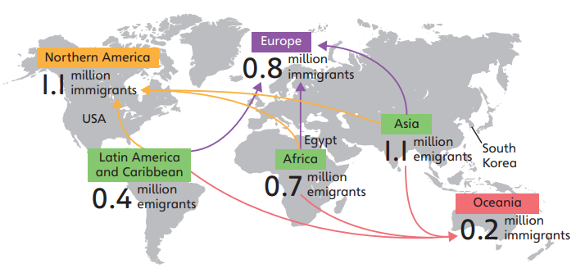

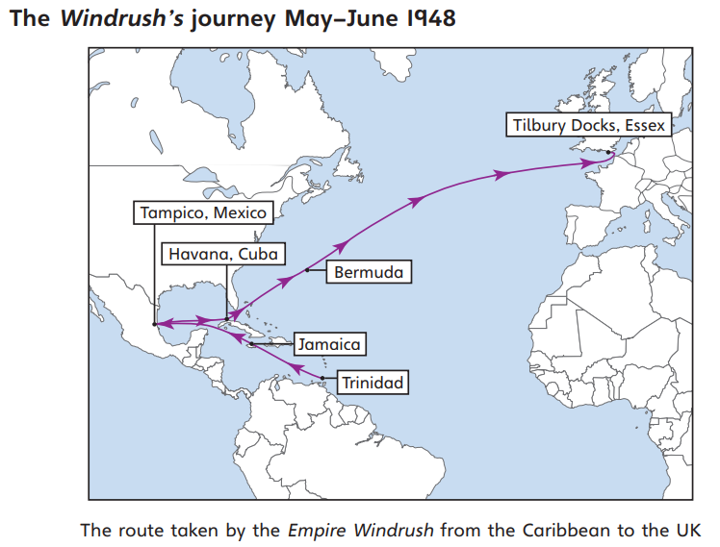

The are many advantages for the host country that occur because migration, but both the host country and source country can suffer from a range of disadvantages due to migration. What are advantages and disadvantages?

Push and Pull Factors

Pull factor - A factor that attracts a migrant to come to a new place

more jobs that pay higher wages

Push factor - A factor that pushes a migrant away from a place

**Push** **Pull**

Windrush generation

Britain used to have an empire (had control over lots of places across the world), and anyone from the British Empire could come to live and work in Britain.

Jamaica was part of the Empire and, at the time, it had high unemployment. There were lots of jobs in Britain, and wages were higher than in Jamaica.

Many of the people who migrated to Britain worked in the NHS, on public transport and for Royal Mail.

**Golden Thread: Sustainability**

Year 4

Spring 1

**Geography – Unit 1 – Migration**

**Working together to be the best that we can be**

