**Golden Thread: Belonging**

**English – Unit 3:** How can I develop my writing skills?

Spring 1

Year 4

**Working together to be the best that we can be**



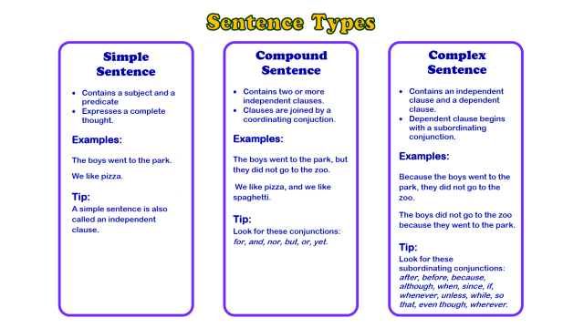

**Nouns**

**☺ Naming words ☺**

**Proper –** *names and places**begins with a capital letter eg. England*

**Abstract –** *thoughts or feelings eg. happiness*

**Concrete –** *things you can touch eg.* *table*

**Verbs –** *action words*

**Adverbs –** *describes the action*

**Adjectives –** *describing words*



**‘ apostrophe**

**, commas**

**! exclamation**

**marks**

**“” inverted**

**commas**

*shows missing letters and possession*

*used in lists, to join clauses, and separate extra information*

*shows exclamations, commands, or strong emotions*

*shows direct speech*

*separate extra information in a sentence*

*shows exclamations, commands, or strong emotions*

*used to join words or add a prefix*

*shows direct speech*

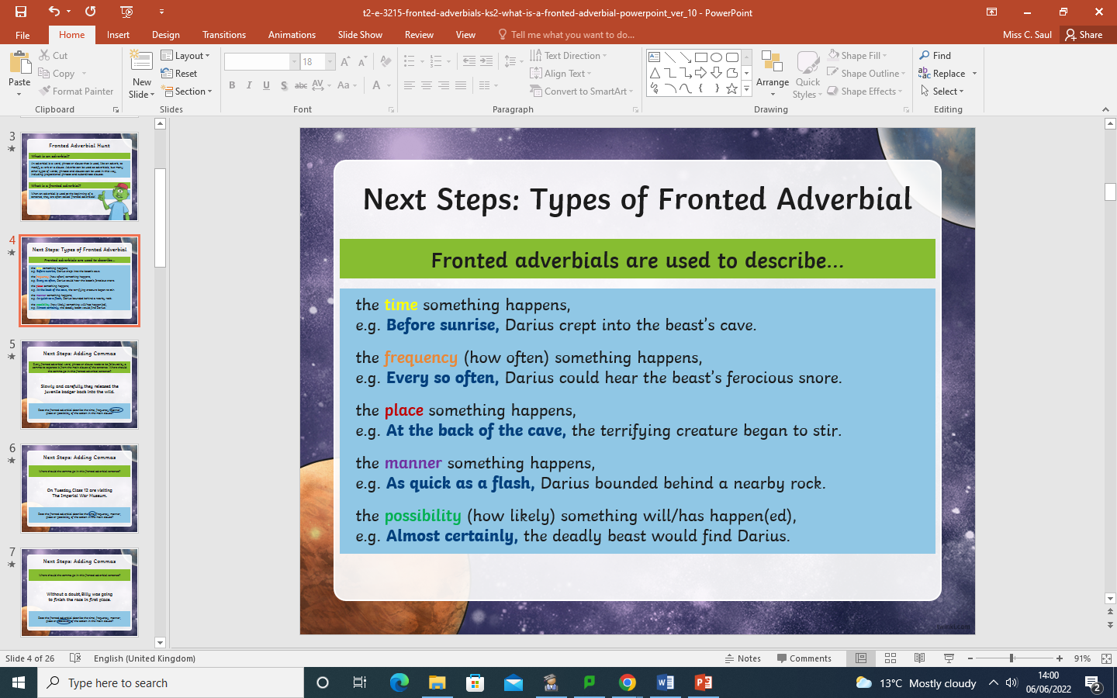

**Fronted Adverbials**

Fronted adverbials come at the start of a sentence. They modify a verb or clause.

*used to join clauses and separate long lists*

*adds tension by creating a pause*

Tenses

Present Perfect

Past

Future

*had*

*will have*

*have, has*