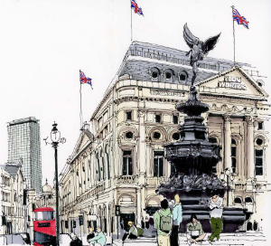

**Working together to be the best that we can be**



**Art – Paint, Surface, Texture – Mixed Media, Land and City Scapes**

Spring 1

Year 5

**Golden Thread: Sustainability**

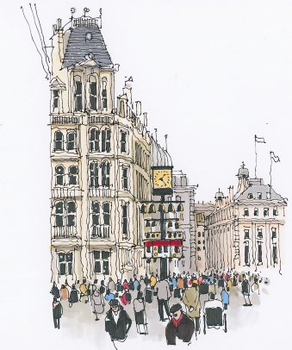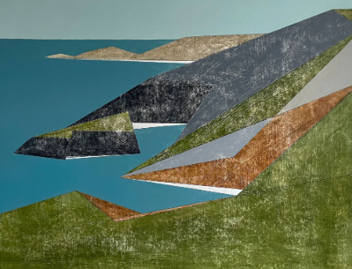

**Landscape**

**Cityscape**

**Working from Life**

**Mixed Media**

**Senses**

**Spirit**

**Energy**

**Capture**

**Composition**

**Format**

**Similarities**

**Differences**

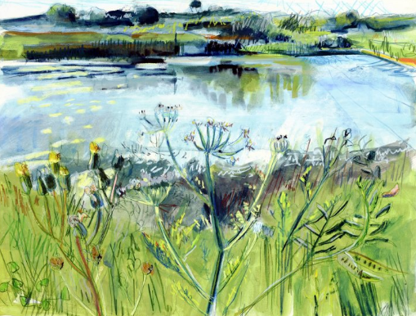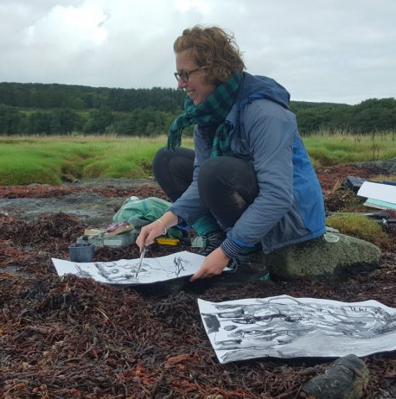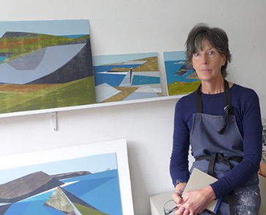

Vanessa Gardiner, Sladers Yard

**Kittie Jones** is an artist based in Edinburgh. Kittie's practice focusses on drawing and printmaking – she produces mixed media drawings on paper out in the landscape, unique multi-layered monotypes and small edition screen prints. Kittie is inspired by the full sensory experience of time spent outdoors.

**Vanessa Gardiner** is an artist living and working in West Dorset. Her landscape paintings concentrate on the dramatic landscapes around Cornwall, Dorset.

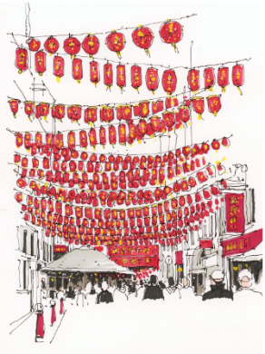

Kittie Jones,

Shadows and Shallows, 2022