**Golden Thread: Sustainability**

**Geography – Unit 1 – Biomes**

Spring 1

Year 5

**Working together to be the best that we can be**



A biome is a huge region with the same sort of climate, plants and animals.

**Talking Points**

What are the Earth’s biomes?

Why are biomes where they are?

Why are biomes under threat?

How can we persuade people to protect biomes?

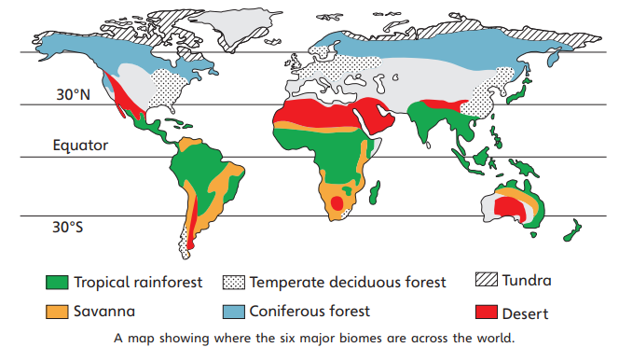

**Key vocabulary**

Adapted - Well suited to living in a particular biome

Biome - Very large region containing the same sort of climate, plants and animals

Climate - General or average weather conditions over a long period of time

Drought - Long period when there is much less rain than usual, leading to there not being enough water

Extinct - No longer alive as a species

Fossil fuels - Resources, such as coal, oil and natural gas, that contain a lot of carbon and release it when they are burnt

Greenhouse gases - Gases like water vapour, carbon dioxide and methane that trap heat in the atmosphere, warming it up

Permafrost - Layer of the ground under the surface that is permanently frozen

Wildfires - Fires that spread very quickly through forests and grasslands

**How climate change affects biomes**

Biomes depend on the climate, so climate change means biome change. The animals and plants of biomes are often adapted to live in their biomes. If the climate changes rapidly, they might not be able to survive there.

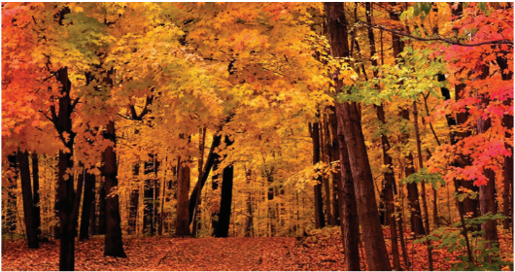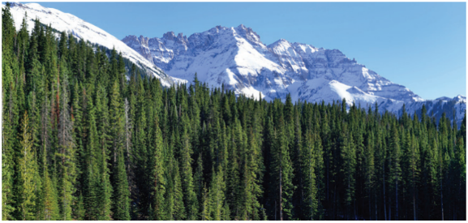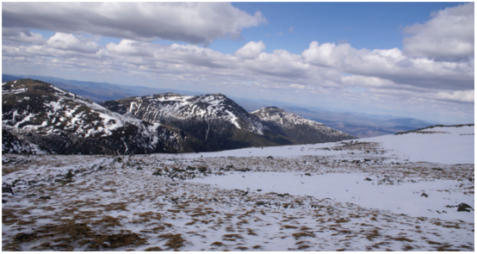

**Golden Thread: Sustainability**

**Working together to be the best that we can be**



Spring 1

Year 5

**Geography – Unit 1 – Biomes**

|  |  |  |
| --- | --- | --- |
| Tropical Rainforest   * Hot all year (25–30°C) * Wet all year (2,000 mm of rainfall a year or more) * Dense forests with several layers of trees | Savanna   * + Hot all year (25–35°C)   + 500–1,000 mm of rainfall a year with a dry season (no rain) * Grasses, some shrubs and some trees that can cope with drought | Desert   * Very hot during the days in summer (35–40°C) * Very low rainfall (250 mm a year or less) * Very few plants: only those that can survive without rainfall |
| Temperate Deciduous Forest   * Four seasons: hot in summer (25°C) and cool in winter (5°C) * Rainfall all year (around 1,000 mm) * Deciduous trees (trees that lose their leaves for winter) | Coniferous Forest   * Mild summers (10–20°C) but very cold winters (below 0°C) * Low rainfall (500 mm a year or less), usually in summer * Evergreen trees (trees that keep their leaves throughout winter) | Tundra   * Cold winters (below −30°C) and cool summers (around 10°C) * Low rainfall (around 200 mm a year) * Very few plants: only those that can survive freezing temperatures and drought |