**Golden Thread: Belonging**

**English – Unit 3:** How can I develop my writing skills?

Spring 1

Year 5

**Working together to be the best that we can be**



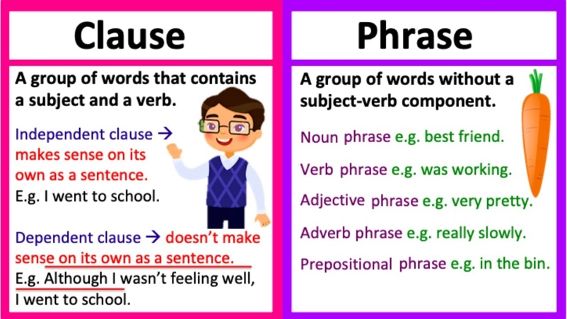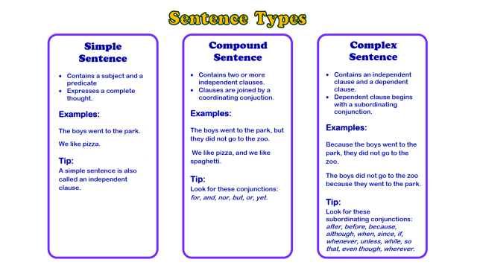

**Nouns**

**Proper –** *names and places**begins with a capital letter eg. England*

**Abstract –** *thoughts or feelings eg. happiness*

**Concrete –** *things you can touch eg.* *table*

*separate extra information in a sentence*

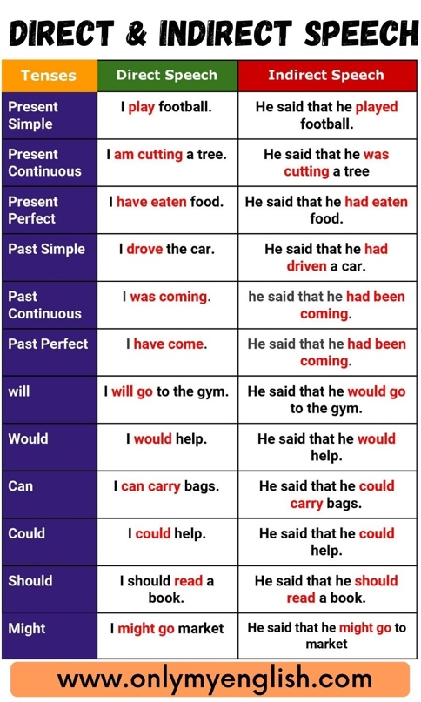*shows exclamations, commands, or strong emotions*

**‘ apostrophe**

**() brackets**

**: colons**

**, commas**

**_ dashes**

**! exclamation**

**marks**

**- hyphens**

**“” inverted**

**commas**

**; semi-colons**

**… ellipsis**

*shows missing letters and possession*

*separate extra information in a sentence*

*used to introduce lists and join clauses*

*used in lists, to join clauses, and separate extra information*

*separate extra information in a sentence*

*shows exclamations, commands, or strong emotions*

*used to join words or add a prefix*

*shows direct speech*

*used to join clauses and separate long lists*

*adds tension by creating a pause*

*used to join words or add a prefix*

*shows direct speech*

*used to join clauses and separate long lists*

*adds tension by creating a pause*