**Golden Thread: Belonging & Social Justice**

**Working together to be the best that we can be**

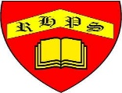

**Art – Collage, Drawing, Sketchbooks – Exploring Identity**

Spring 1

Year 6

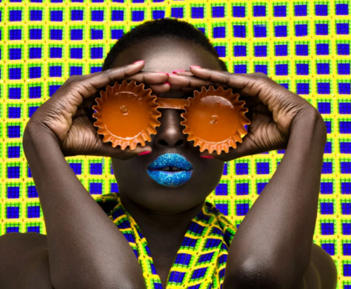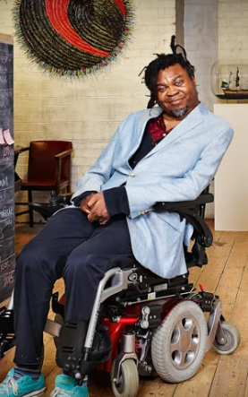

### Artist - Photographer Thandiwe Muriu

### Artist - Njideka Akunyili Crosby

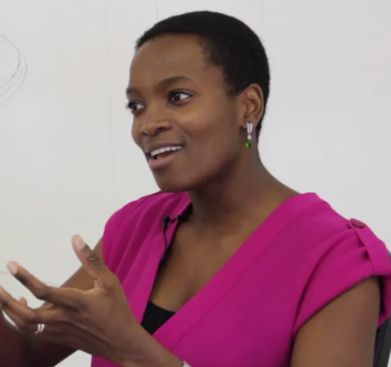

### Artist - Yinka Shonibare

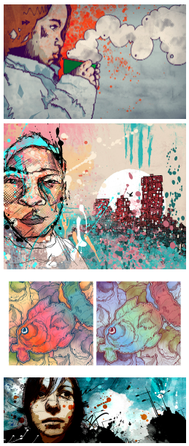

Identity

Layer

Constructed

Portraiture

Layering

Digital Art

Physical

Reflect

Respond

Articulate

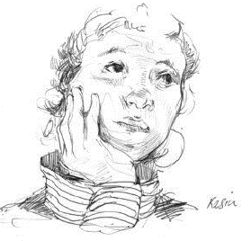

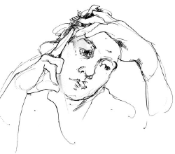

Portrait Club

Making layered portraits – by Mike Barrett