**Geography – Unit 1 – Population**

**Golden Thread: Belonging/Civilisations**

Spring 1

Year 6

**Working together to be the best that we can be**



**Talking Points**

Where do people live around the world?

How and why has population changed?

What are the challenges of an ageing populations?

What are the best ways to feed a planet?

|  |  |
| --- | --- |
| **Population changes** | |
| Rapidly growing | Increase pressure on resources, land and services (such as health and education) |
| Ageing | Increase pressure on health services, fewer people working, increased elderly poverty |
| Food | One in nine people still go hungry everyday, food production is not increasing quick enough |

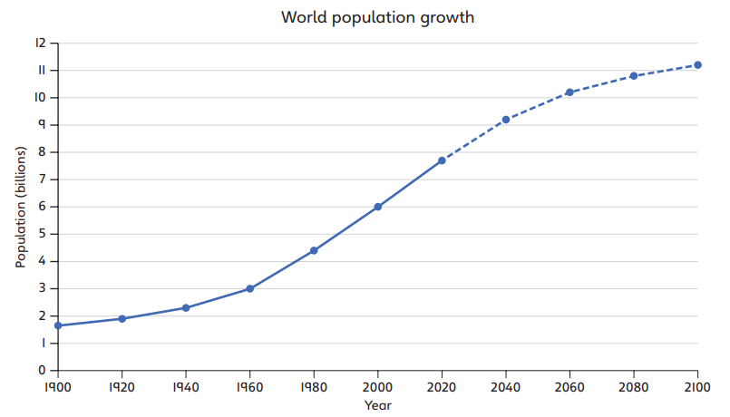

**Key vocabulary**

Birth rate - The number of births per 1,000 people per year.

Death rate - The number of deaths per 1,000 people per year.

Densely populated - Many people live in the area. For example: cities such as Manila in the Philippines and Milan in Italy.

Food insecurity - Being without reliable access to enough affordable and nutritious food.

Food production - Growing food for people to eat.

Life expectancy - The average age that a person is expected to live to.

Population - The number of people who live in a particular place.

Population density - The number of people living in one square kilometre.

Sparsely populated - Very few people live in the area. For example: rural areas such as the Scottish Highlands.

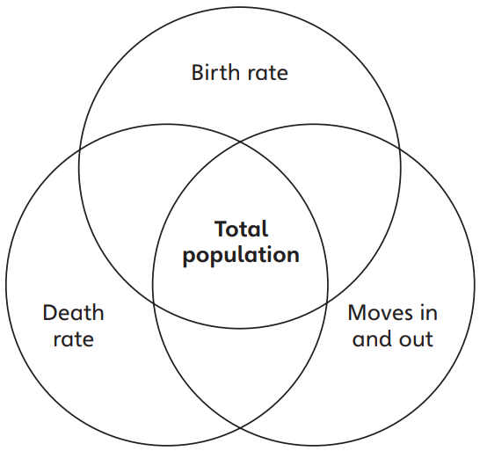

There are a variety of factors that impact the population.

There are factors that increase and decrease the population. Each factor helps to control whether the population rises, or decreases over time. They are interlinked, which means one will depend on the other.

Population changes impact people’s settlements but also our environment.

Birth rate, death rate and migration will impact the population of a country.

**Working together to be the best that we can be**



Spring 1

Year 6

**Golden Thread: Belonging/Civilisations**

**Geography – Unit 1 – Population**