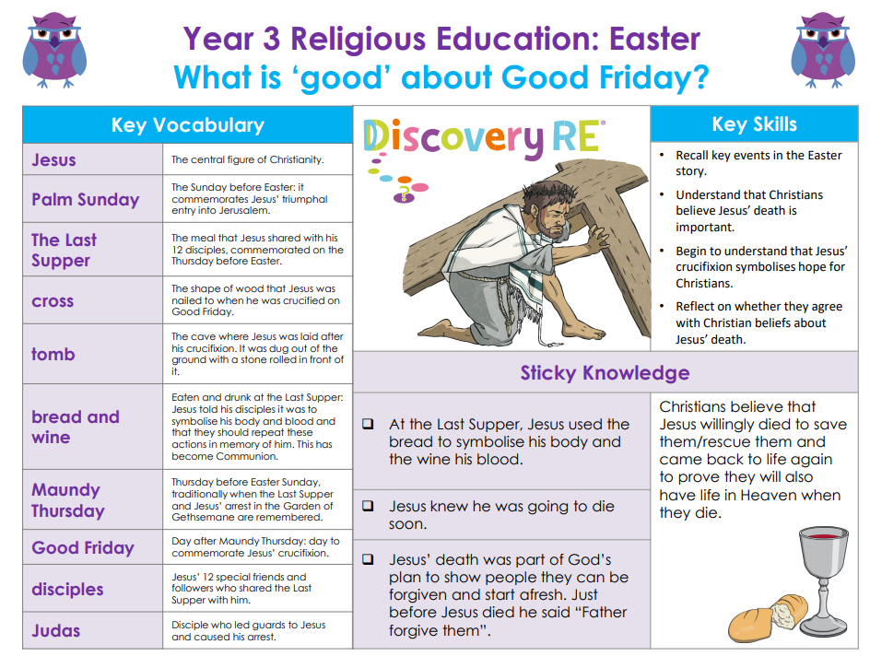

RE – Unit 4 – Christianity: What is ‘good’ about Good Friday?
Working together to be the best that we can be
Golden Thread: Belonging

Spring 2
Year 3

