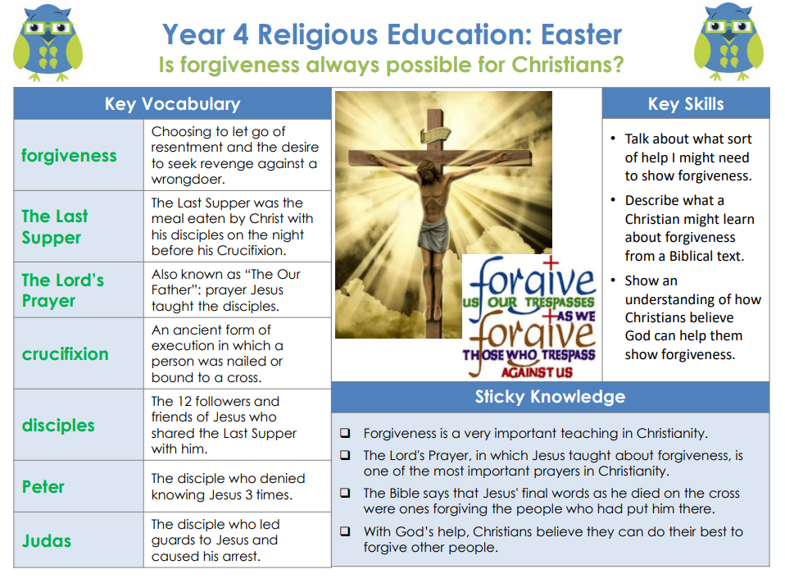

Golden Thread: Social Justice

RE – Unit 4 – Christianity: Is forgiveness always possible for Christians?

Working together to be the best that we can be
Spring 2
Year 4

