
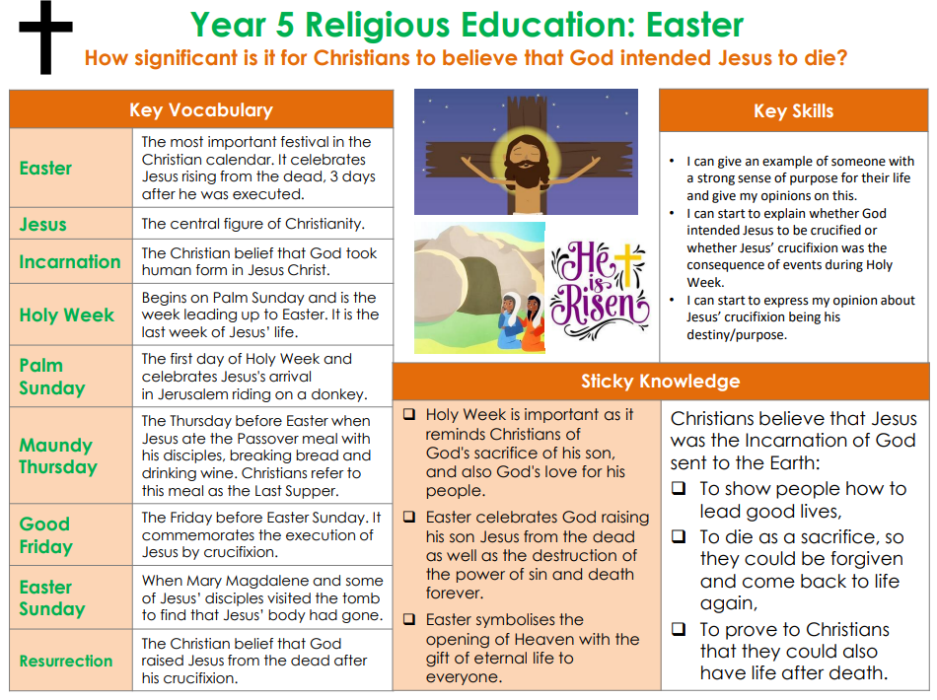

Golden Thread: Social Justice

RE – Unit 4 – Christianity: How significant is it for Christians to believe that God intended Jessus to die??

Working together to be the best that we can be
Spring 2
Year 5

