
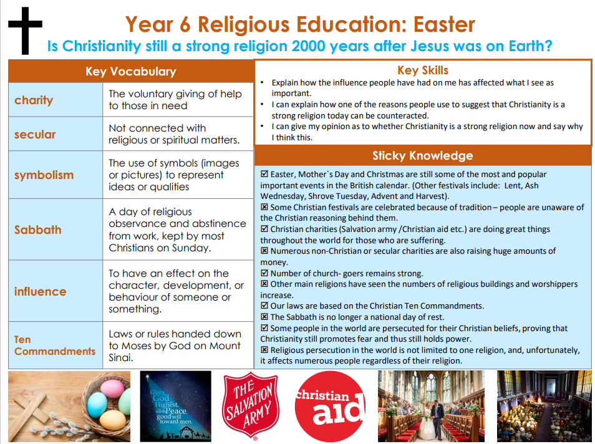

RE – Unit 4 – Christianity: Is Christianity still a strong religion 2000 years after Jesus was on Earth?
Working together to be the best that we can be
Golden Thread: Belonging

Spring 2
Year 6

