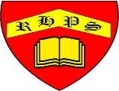
Golden Thread: Material Culture
DT: Textiles: Combining different fabric shapes

Spring
Year 5
Working together to be the best that we can be
