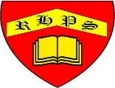
Golden Thread: Technological Advancement
Spring
History- Travel and Transport
Year 2
Working together to be the best that we can be

