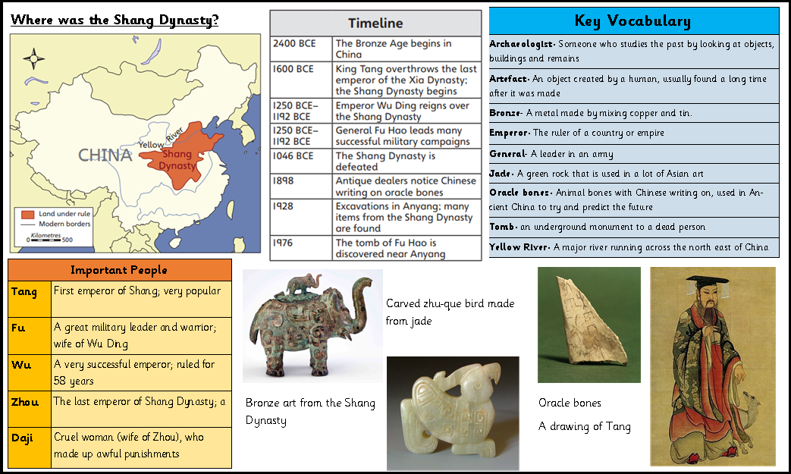
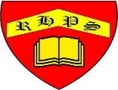
Spring
Year 3
History- Prehistoric Britain
Golden Thread: Civilisations
Working together to be the best that we can be

