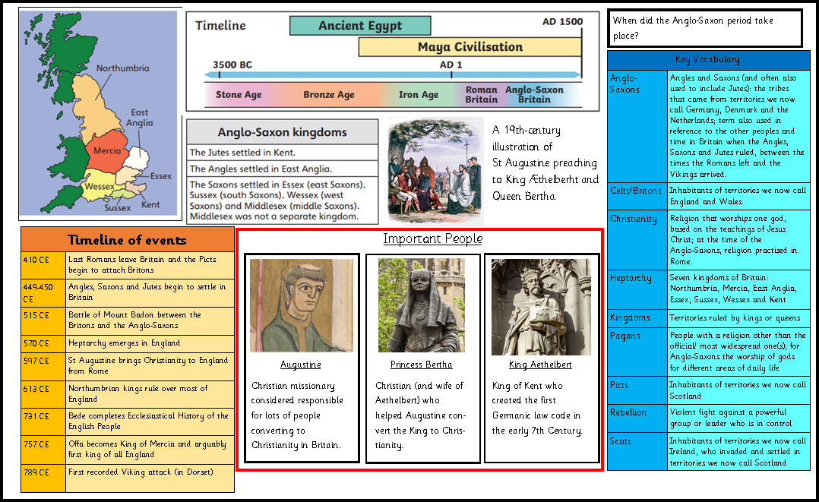

Spring
Year 4
History- Anglo-Saxon Britain
Golden Thread: Civilisations
Working together to be the best that we can be
