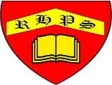
Golden Thread: Material Culture
History- Medieval Monarchs
Spring
Year 5
Working together to be the best that we can be
