Money
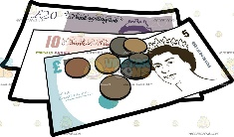  What is Money and How is it Used?  -Money is used to pay for things.  -Money is made up of coins and notes. The UK money system is the pound.  -Money is also used to pay people for work.  -As we get older, we may get pocket money or jobs to earn our own money. | 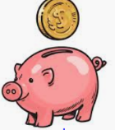  Looking after Money  -We have a responsibility to look after our money.  -A wallet or a purse can be used to store money that we plan to spend. Some people use a piggy bank to save up their money.  -Larger amounts of money can be saved in a bank.
Staying Healthy and Safe
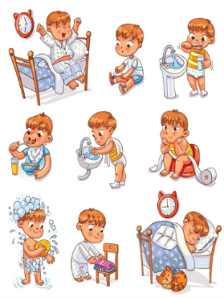
Daily Routines
-To stay healthy and safe, there are a number of things that we should make a part of our daily routines.
-Daily routines are the tasks and duties that we do every day.
Some examples of daily routines that keep us healthy & safe are:
-Brushing our teeth: to keep our teeth & mouth healthy & clean.
-Washing and bathing: to keep our hair & bodies healthy & clean.
-Washing our hands regularly (especially after using the toilet and before eating): to make sure that germs are not spread and to stop us from getting ill.
-Going to sleep: to help keep our minds fresh, alert and healthy.
-Using a tissue to blow our nose: to make sure that germs are not spread.

Working together to be the best that we can be
PSHE – Rights and Respect
Year 1
Spring 2
Golden Thread:
Rights and Respect
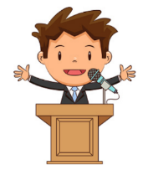
We are learning about the things that we should have (our rights) and the things that we should do (our responsibilities).
You should already know that: There are some things that we are responsible for, e.g. looking after ourselves, other people and our things.

People and Environments
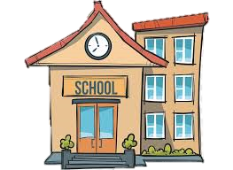  Our School  -Schools are places that have been designed for children. Headteachers and teachers think carefully about how to make schools a nice place for children to learn.  -Everybody has a responsibility for looking after the school, including staff and children. This includes:  -Keeping it clean and tidy. Picking up litter and cleaning up mess after ourselves.  -Looking after school equipment carefully.  -Wiping our feet when we come indoors.  -Putting things in their proper places. | 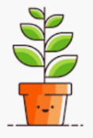  Living Things  -Living things, like people, animals and plants, need looking after in order to be healthy and safe.  -For example, a pet cat needs to have food, water, shelter and love in order to grow and flourish    First Aid: This is the help and care that we can give to someone who is sick or injured.  -We should learn to spot dangers, so that there is less chance of accidents happening.  -When we see someone is badly hurt or sick we should call 999.

