Money
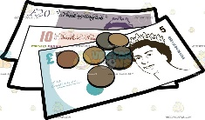  What is Money and How is it Used?  -Money is used to pay for things.  -Money is made up of coins and notes. The UK money system is the pound.  -Money is also used to pay people for work.  -As we get older, we may get pocket money or jobs to earn our own money. | 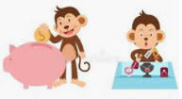  Spending and Saving  -We all have choices about how whether to spend our money or save it.  -Spending allows us to buy things that we want. Saving our money can help us to buy more expensive things. It is also useful in case we need to spend money on something unexpected.
Staying Healthy and Safe
Feeling Safe
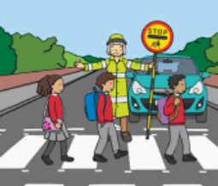
-It is important that we feel safe. Some places where we may feel safe include home, school, or a family member’s home.
However, we need to recognise that some things are not safe for us to do alone. In these cases, we need to get help from a trusted adult. Examples include: crossing a busy road; when using sharp objects/ equipment; when cooking or when our ball goes onto a roof!
-Sometimes, we need to get a specialist (someone who is trained in an area) to help us. E.g, if someone was badly injured or sick, we would need to call for an ambulance.
1. Call 999 for the emergency services (police, ambulance, or fire services);
2.Tell the person on the phone what has happened (as clearly and quickly as you can) and they will decide who is best to help you.

Working together to be the best that we can be
PSHE – Rights and Respect
Year 2
Spring 2
Golden Thread:
Rights and Respect
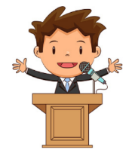
We are learning about the things that we should have (our rights) and the things that we should do (our responsibilities).
You should already know that: There are some things that we are responsible for, e.g. looking after ourselves, other people and our things.

People and Environments
Looking After the Environment  -Our environment is the name given to everything that is in the world around us, both natural and man-made.  -E.g. The trees and fields are natural, and the school building and your house are man-made features of the environment.  -Everybody has a responsibility for looking after the environment, including adults and children. This includes:  -Keeping it clean and tidy.  -Not using too many resources. Recycling.  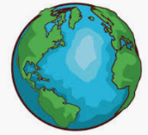  -Returning things as we have found them.  -Respecting all of the living things around us. | 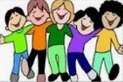  Getting on with Others  -It is important to think about what other people need in order to be happy and do their best.  Some ideas include: Sharing, returning things, taking turns, listening, helping others, being kind and compassionate.    First Aid: This is the help and care that we can give to someone who is sick or injured, before full medical help arrives.  -We should learn to spot dangers, so that there is less chance of accidents happening.

