Money
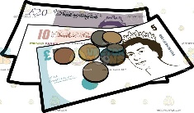  What is Money and How is it Used?  -Money is used to pay for things.  -Money is made up of coins and notes. The UK money system is the pound.  -Money is also used to pay people for work.  -As we get older, we may get pocket money or jobs to earn our own money. | 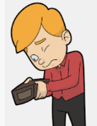  What Can I Afford?  -Before buying things, we should always consider:  -How much it costs  -How much it is needed/wanted  -How much money will be left  -What other things we need to buy  - Whether it can be bought cheaper elsewhere, and whether there are better versions of the same product.
Staying Healthy and Safe
Keeping Each Other Safe
-There are many people in our everyday lives who help to keep us safe, including:
-Doctors and nurses, who help to prevent and treat illnesses and injuries;
-The police, who help to make sure that we are safe from people who break the law;
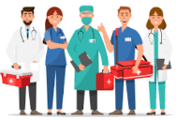
-Our parents, who keep us safe in lots and lots of different ways!
We can help these people to keep us safe by following their instructions carefully.
Volunteers
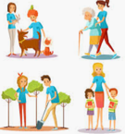
-A volunteer is someone who chooses to work or give their time free of charge. They often do so because they want to help make a positive difference to someone or something.
-Volunteering is one way to have a positive impact on the lives of other people. It also helps the volunteer to feel happy; research has shown that helping others increases the happiness of those that give help.
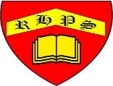
Working together to be the best that we can be
PSHE – Rights and Respect
Year 3
Spring 2
Golden Thread:
Rights and Respect
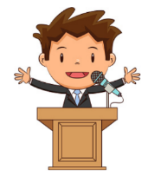
We are learning about the things that we should have (our rights) and the things that we should do (our responsibilities).
You should already know that: There are some things that we are responsible for, e.g. looking after ourselves, other people and our things.

People and Environments
Looking After the Environment  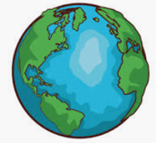  -Our environment is the name given to everything that is in the world around us, both natural and man-made.  -Everybody has a responsibility for looking after the environment, including adults and children.  You should be able to think of some ways that you can help the environment around you (school or home), for example by thinking of:  -Ways to reduce waste (e.g. by saving paper etc.); Ways to save water; Ways to save energy; Ways to look after plants/animals in the environment. | First Aid: This is the help and care that we can give to someone who is sick or injured, before full medical help arrives.  -We should learn to spot dangers, so that there is less chance of accidents.    -When we see that someone is badly hurt or sick, we should call 999 for the emergency services.

