Money
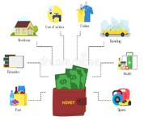  Income and Expenses  -Income is the amount of money that a person or organisation receives, and expenses are the money that it spends.  -Some expenses are essential (things we need - electricity and water) whilst some are things that we want rather than need).  -People and organisations need to carefully calculate their income and expenses to make sure that they don’t run out of money. | 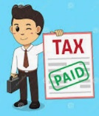  Taxes  -Tax is money that people pay to the state to help it run. There are different types of tax:  -Income tax is money that comes out of peoples’ wages, to pay for things like hospitals, police and schools.  -National Insurance is used to pay for state pensions and other benefits.  -VAT means value added tax, and is paid when we buy certain items.
Staying Healthy and Safe
Helping us to Stay Healthy and Safe
-There are many people in our everyday lives who help to keep us healthy and safe, including:
Teachers Doctors Police Crossing Patrol Firefighters School Caretakers
School Administrators Paramedics Nurses
Responsibilities  -All of the above people have responsibilities to keep us healthy and safe. Responsibility can be defined as:  1.) Looking after a person or thing  2.) Being reliable and trustworthy  3.) Having important duties. | Safety in Numbers  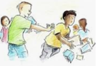  - Bystanders are people who see or hear an event taking place, but are not directly involved.  -The behaviour of bystanders has a huge impact on people’s behaviour. They can change things for the better!  -When a group works together, they are far more powerful than one person alone.
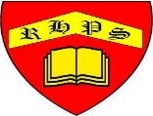
Working together to be the best that we can be
PSHE – Rights and Respect
Year 4
Spring 2
Golden Thread:
Rights and Respect
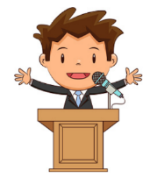
We are learning about the things that we should have (our rights) and the things that we should do (our responsibilities).
You should already know that: There are some things that we are responsible for, e.g. looking after ourselves, other people and our things.

People and Environments
Rules and Laws  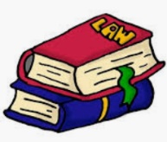  -Rules and laws are there to protect everybody and keep us all safe and healthy.  -There are rules in school, e.g. no running around the classroom (to reduce accidents) and laws in society, e.g. Follow the speed limit in a car (again, to reduce accidents and injuries).  -There are 195 countries in the world and each country has their own laws and rules to keep people healthy and safe.  -Even though they are there to help us, there are some rules that we might find more difficult to follow, e.g. going to bed at bedtime, not playing sports inside, etc.  -We should be able to think of some strategies to help us to follow rules | 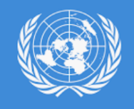  Your Rights  - The United Nations is an organisation made up of countries that want to work together in a peaceful way.  -It represents almost all of the countries in the world (193 at the last count) and holds a list of rights for children.  -Rights for children can be described as things that every child should have or be able to do in order to them be healthy, safe and happy. These rights include:  -A right to play outside  -A right to eat a healthy diet  -A right to be treated by doctors when ill  -A right to be safe at all times  -A right to go to school

